Week 4 Lab

# Terraform Modules, Functions, Conditions

# Deployment of Fault-Tolerant Web Application with Terraform

Pratham Sapra  
Student ID: 148047236

## The Goals

In this lab, we will firstly introduce more Terraform features, such as Terraform functions, conditions, and state manipulation commands. (Tasks 1-3)

As a next step, we will use all the knowledge acquired so far to improve the Terraform config we created in Week 3. We will deploy a static webserver on Amazon EC2.

We will continue to improve the reusability, modularity, and extensibility of our Terraform code. In addition to Terraform improvements, we will move away from the use of Default VPC and will create our own Virtua Private Cloud (VPC) in AWS and make our web site deployment fault tolerant.

The modularity of our code will support deployment into multiple environments, such as Test and Prod.

## Task 1: Use of functions and conditions – Support of Multiple Environments with Terraform

## Week 3 Architecture

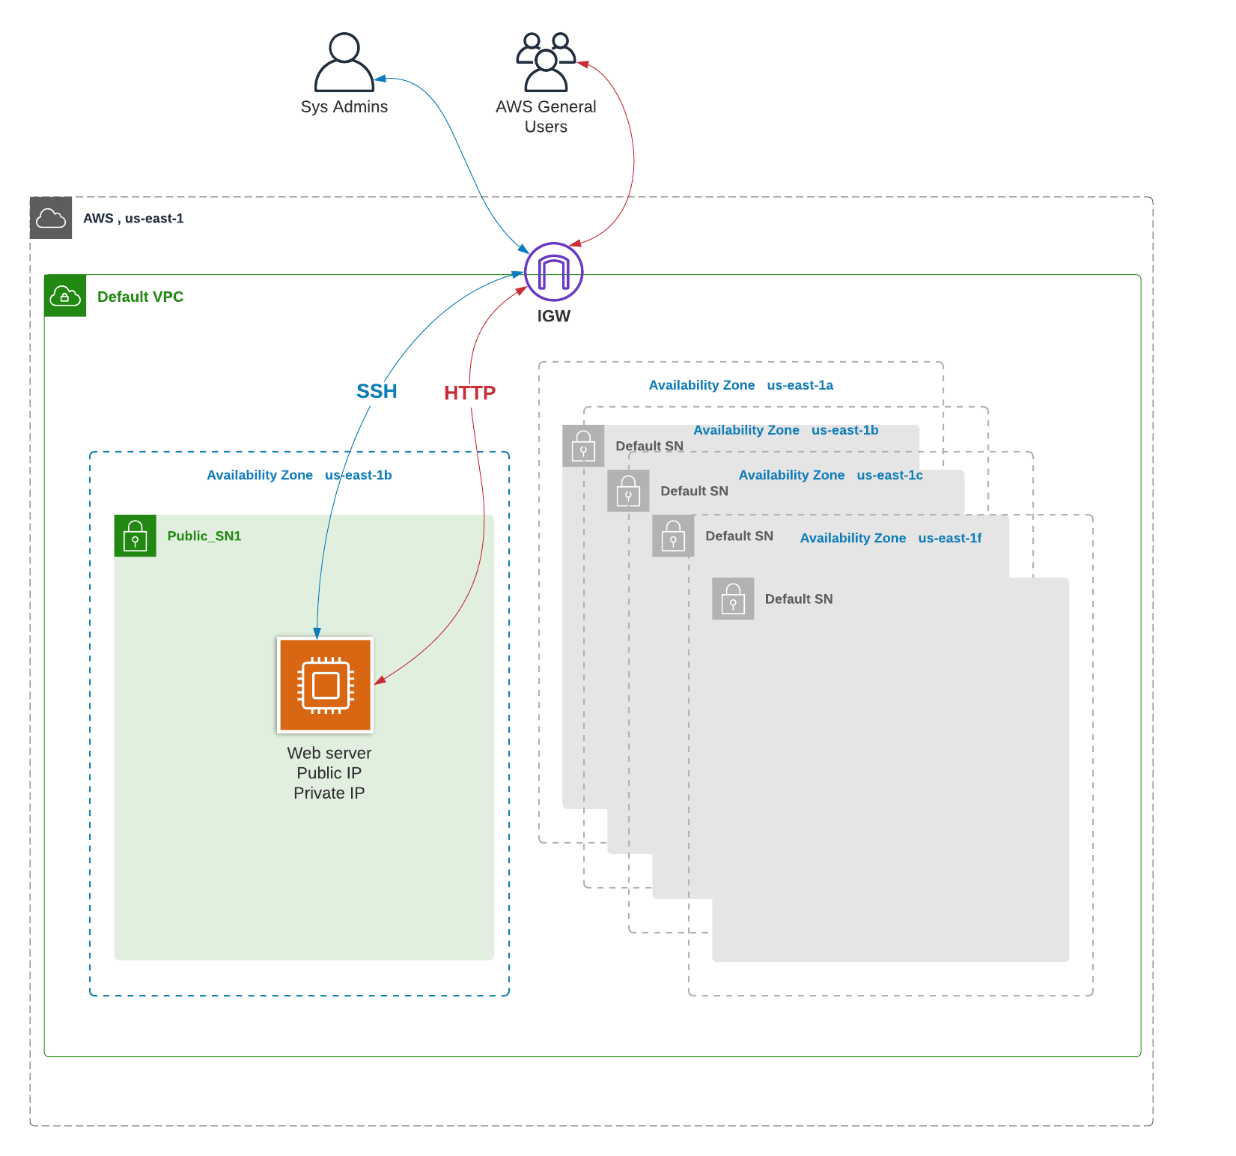

Figure 1Week 3 Architecture

Start with the code provided in BB, Learning Content => Week 4 => Lab =>week4-terraform_code => Session 1 => week4_task1_start.

Our goal in Task 1 is to use the implement different deployments of our infrastructure into Test and Prov environments. We will use Terraform input parameters and conditions to create code that supports deployments in Prod and Test environments.

Prod environment is more evolved and has the requirements below:

* Root volume is encrypted in Prod only
* Additional data volume is deployed in Prod only
* EC2 instance type is t2.medium; all the other environments should be using t2.micro

**Note**: you can see the solution in week4_task1_result yet I recommend you build it out by yourself

1. Create an S3 bucket to store the remote Terraform state. The bucket should be created manually. Update config.tf files to reference this bucket.

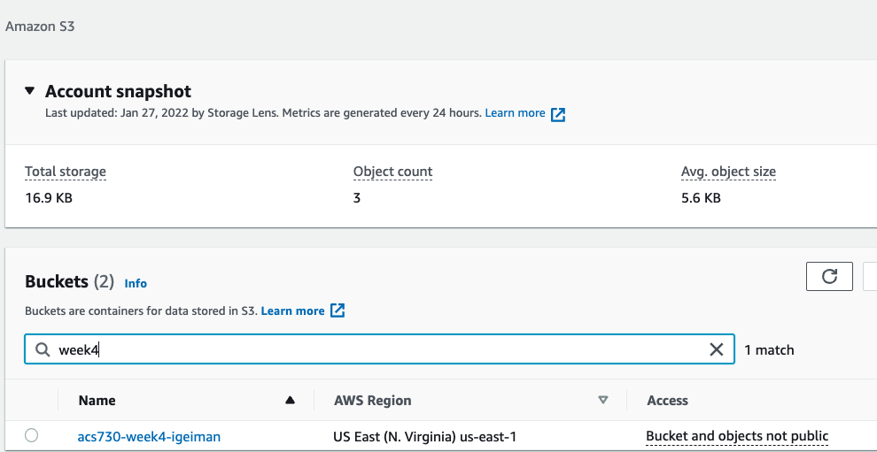

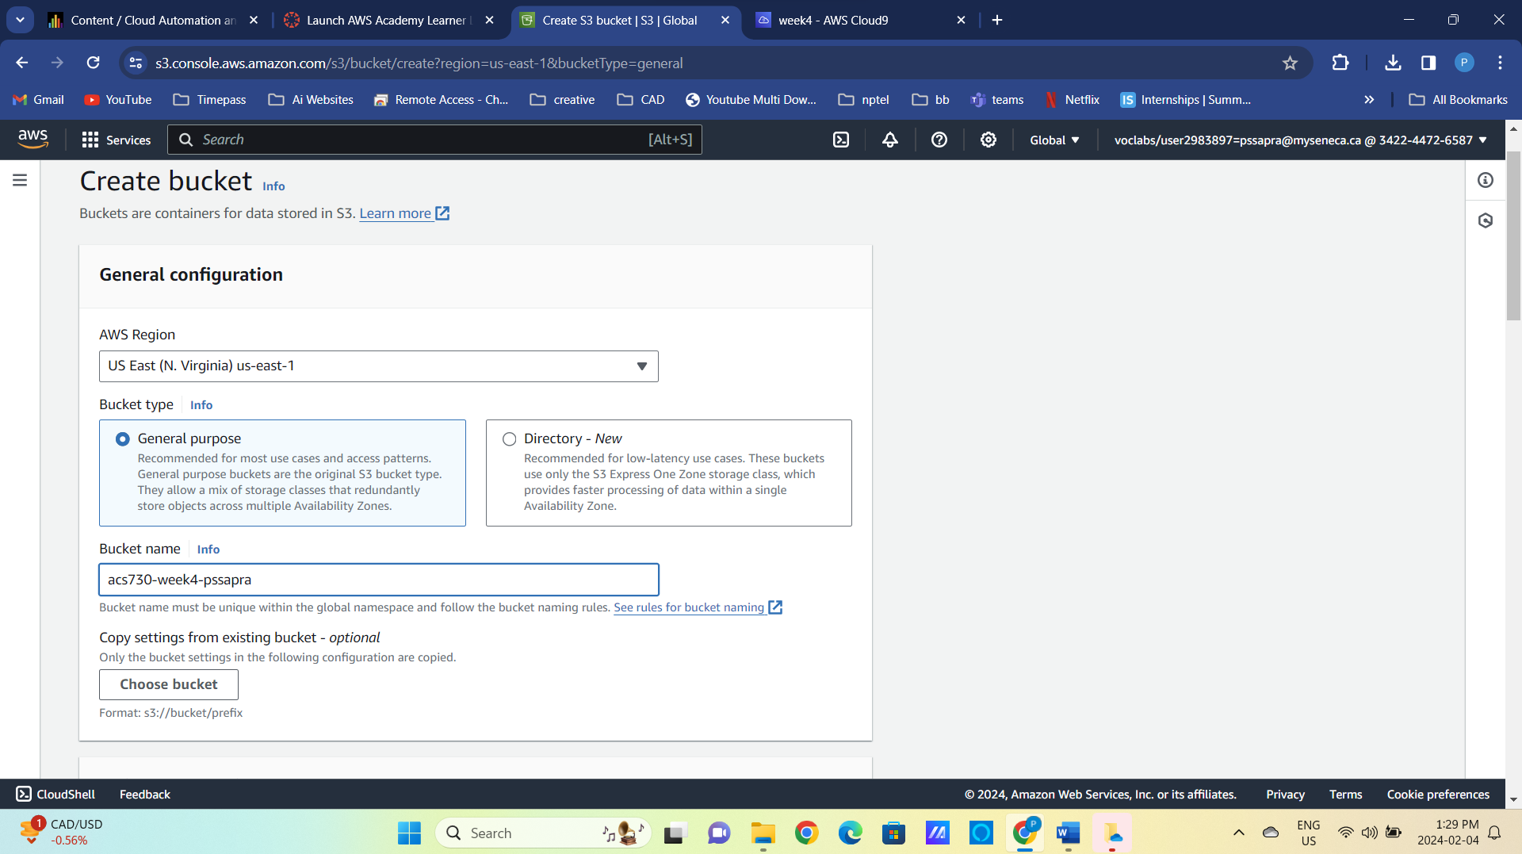

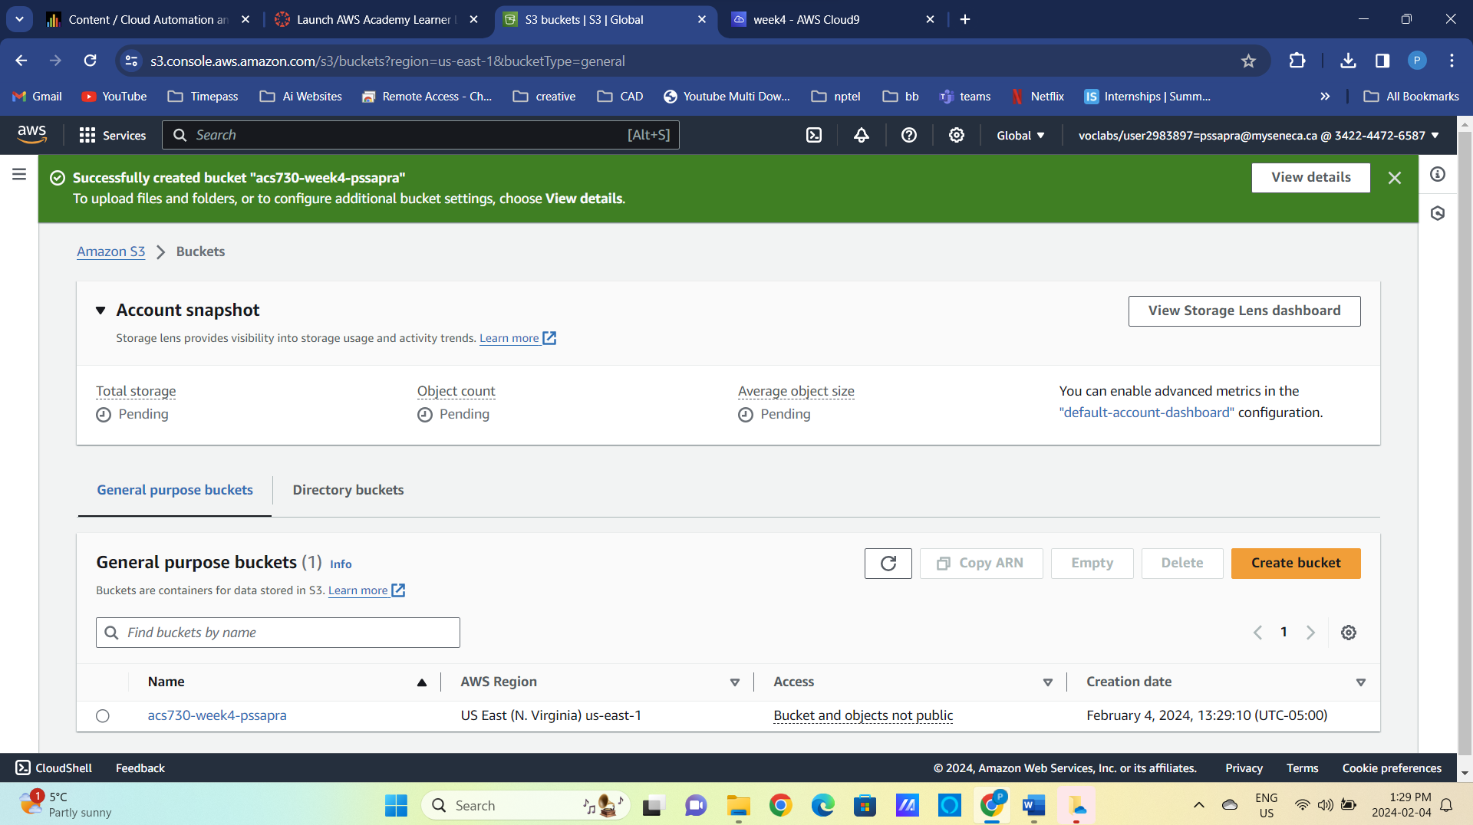

Figure 2 S3 bucket to store the state

1. Change directory to week4_terraform_code/Session 1/01_task1_start/01-Networking folder and create a new public subnet in default VPC.

cd week4_terraform_code/Session 1/01_task1_start/01-Networking

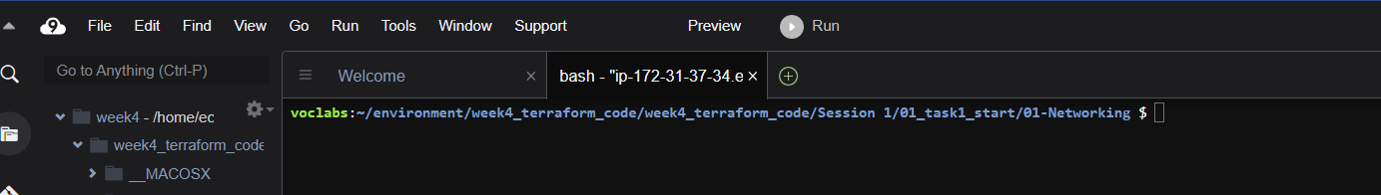

terraform int

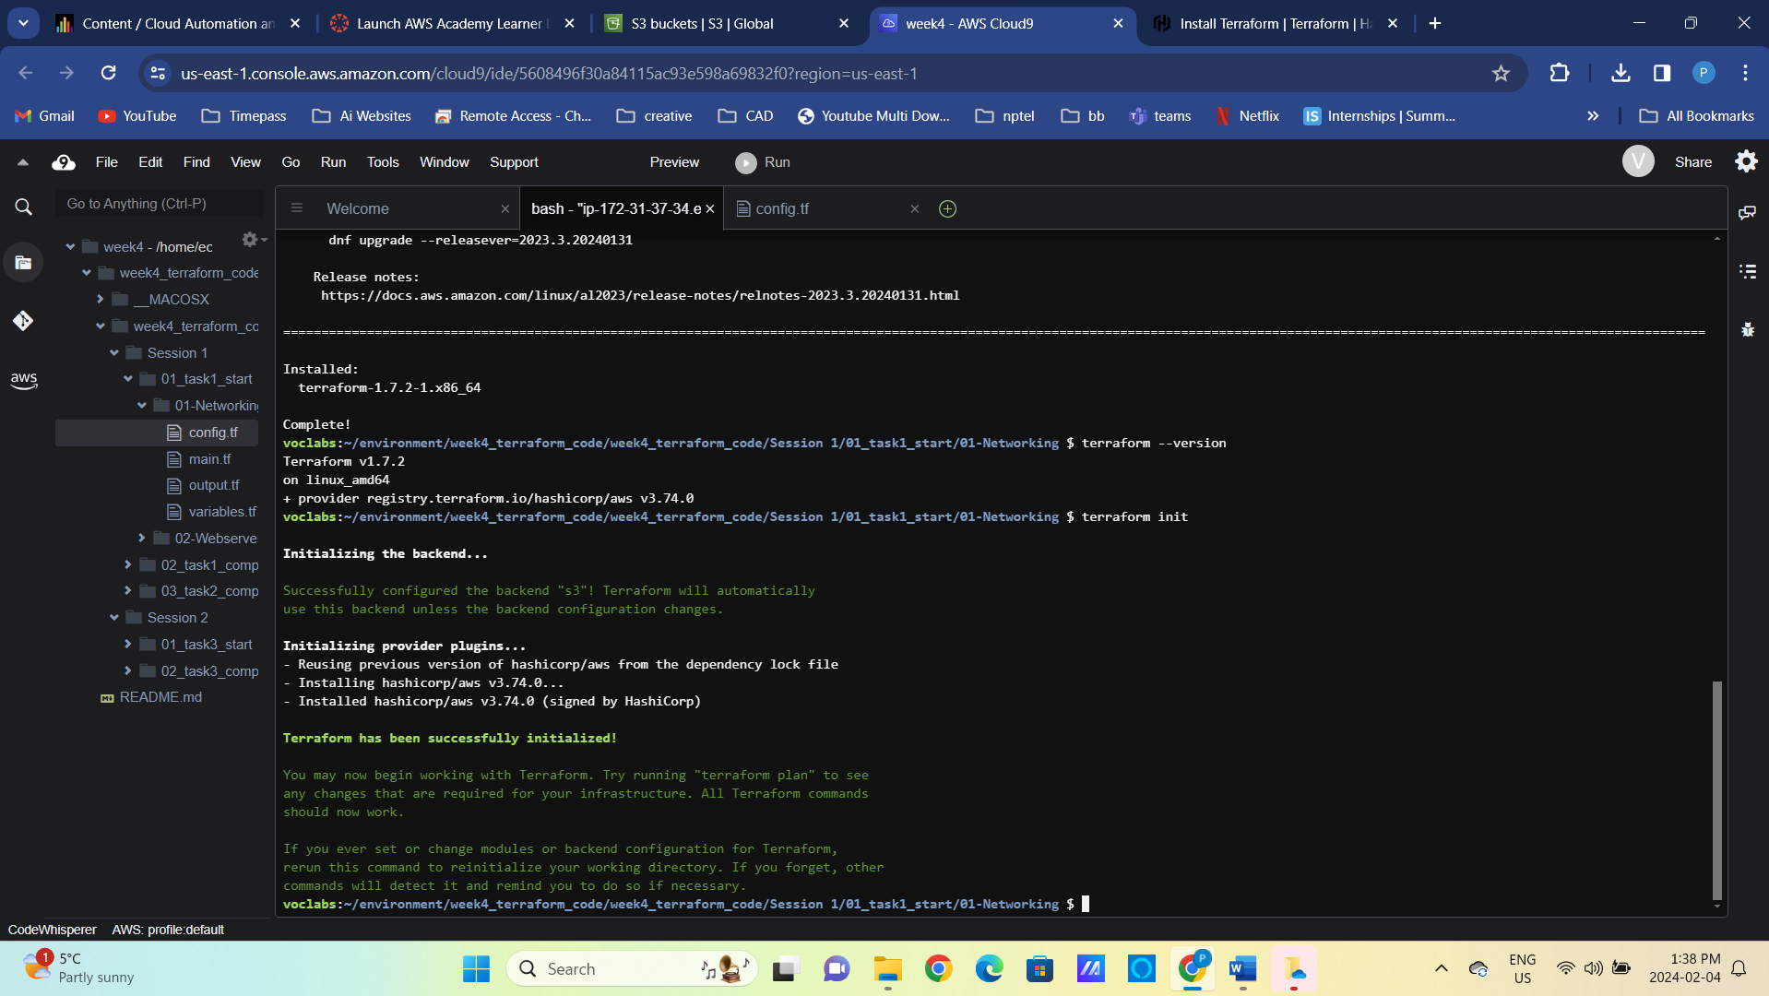

Figure 3 Terraform init in 01-Networking

terraform validate

terraform plan

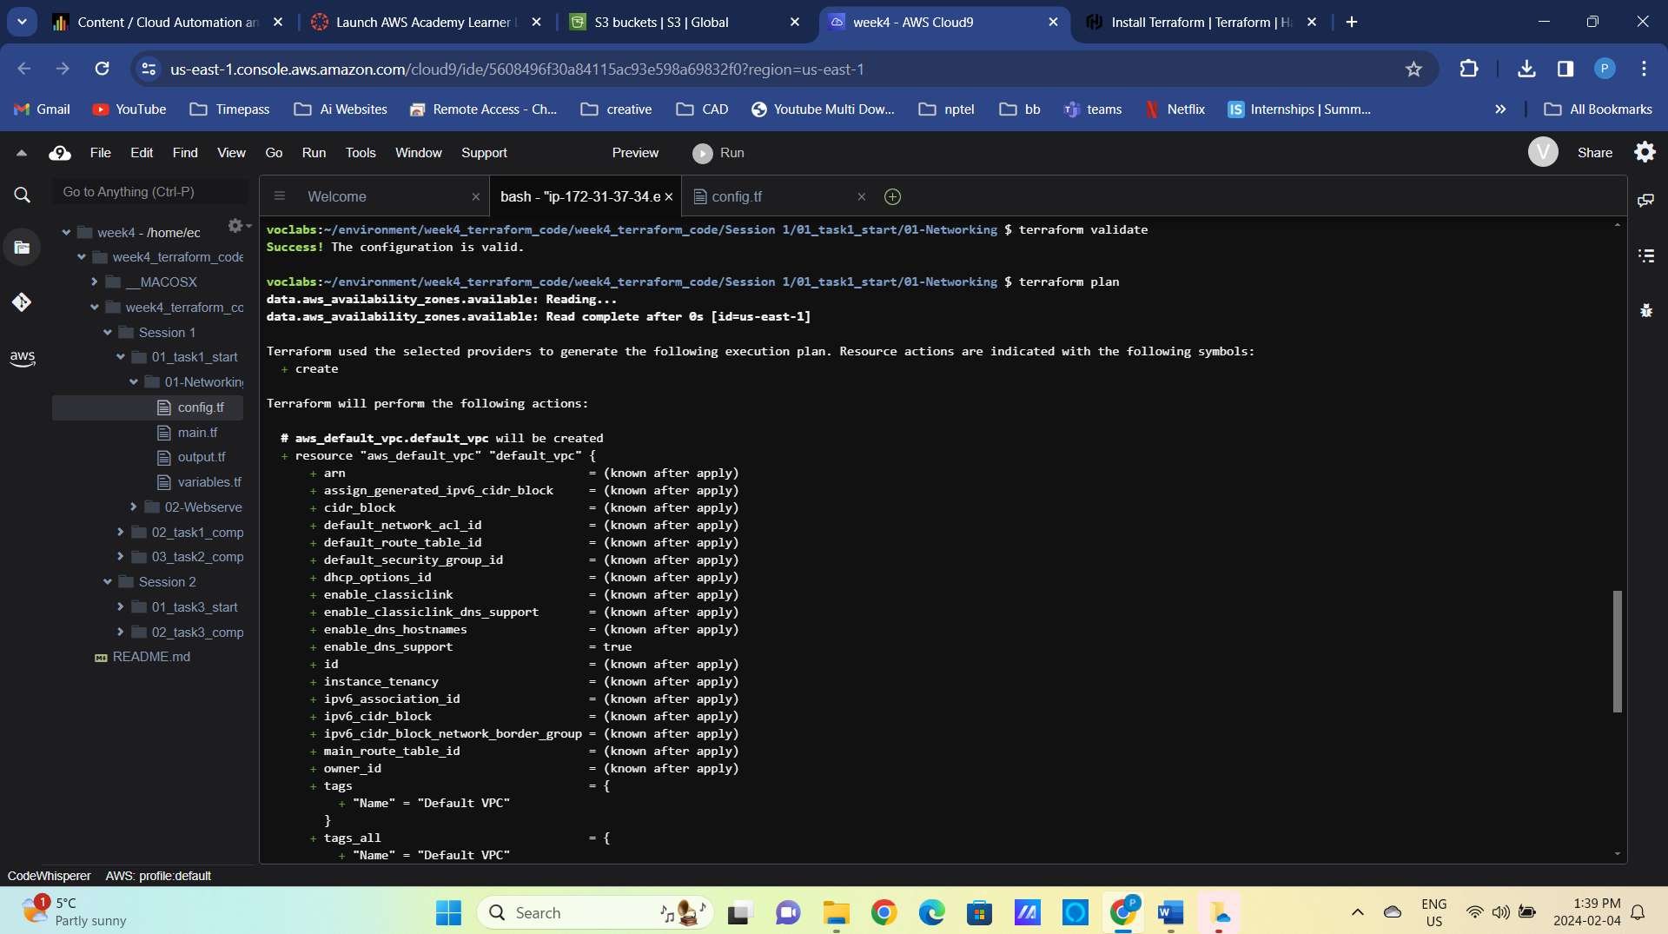

terraform apply –auto-approve

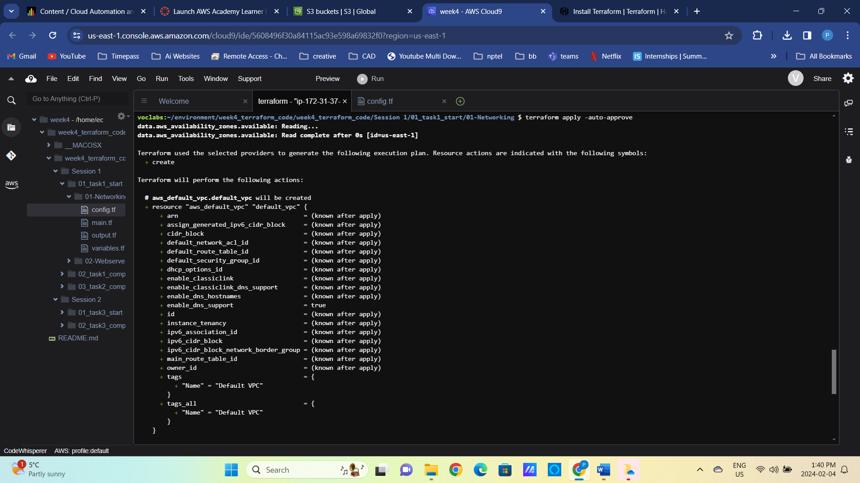

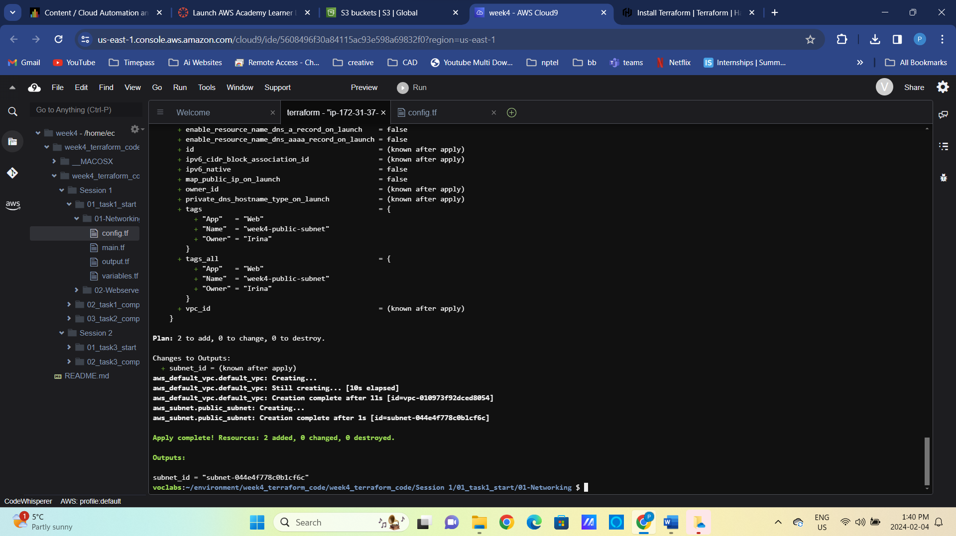

Figure 4 Results of terraform apply

1. Change directory to week4_terraform_code/Session 1/01_task1_start/01-Webserver and deploy the EC2 instance into the subnet we just created. Do not forget to update the bucket name in the file and to create a new ssh key pair for week4.

cd ../02-Webserver

ssh-keygen -t rsa -f week4

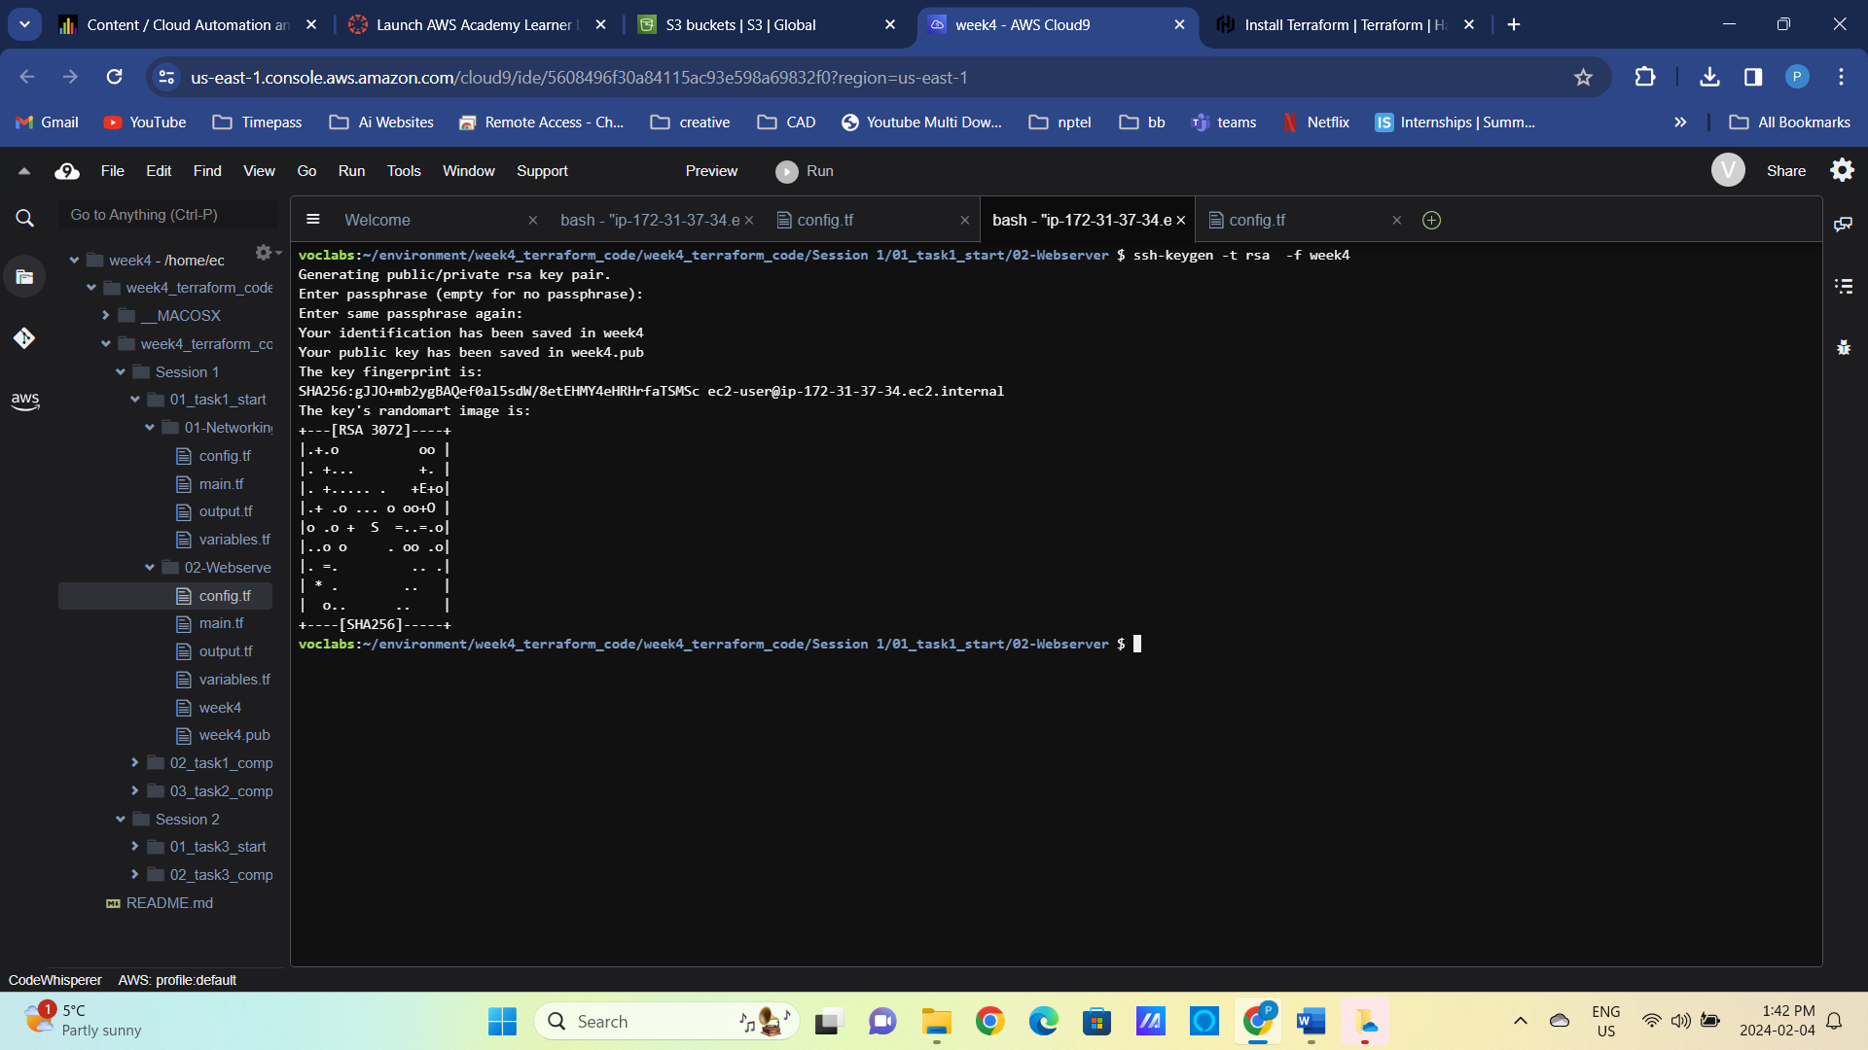

Figure 5 List files in the current folder

terraform int

terraform validate

terraform plan

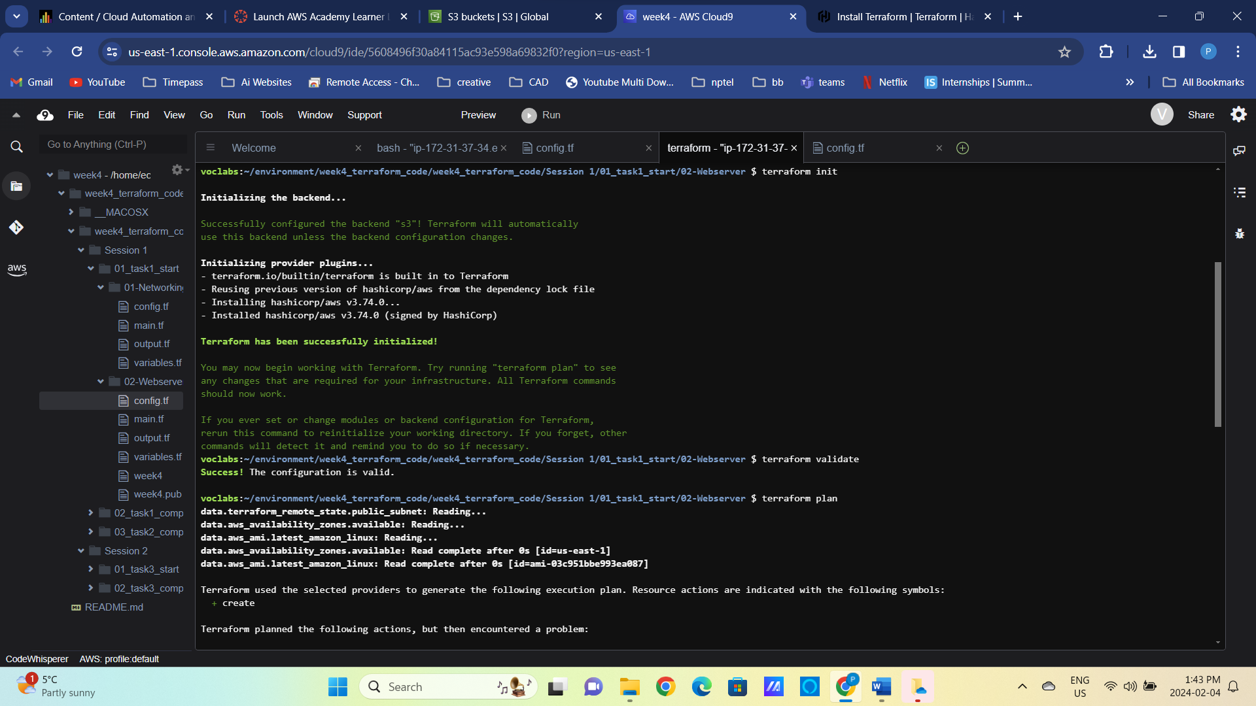

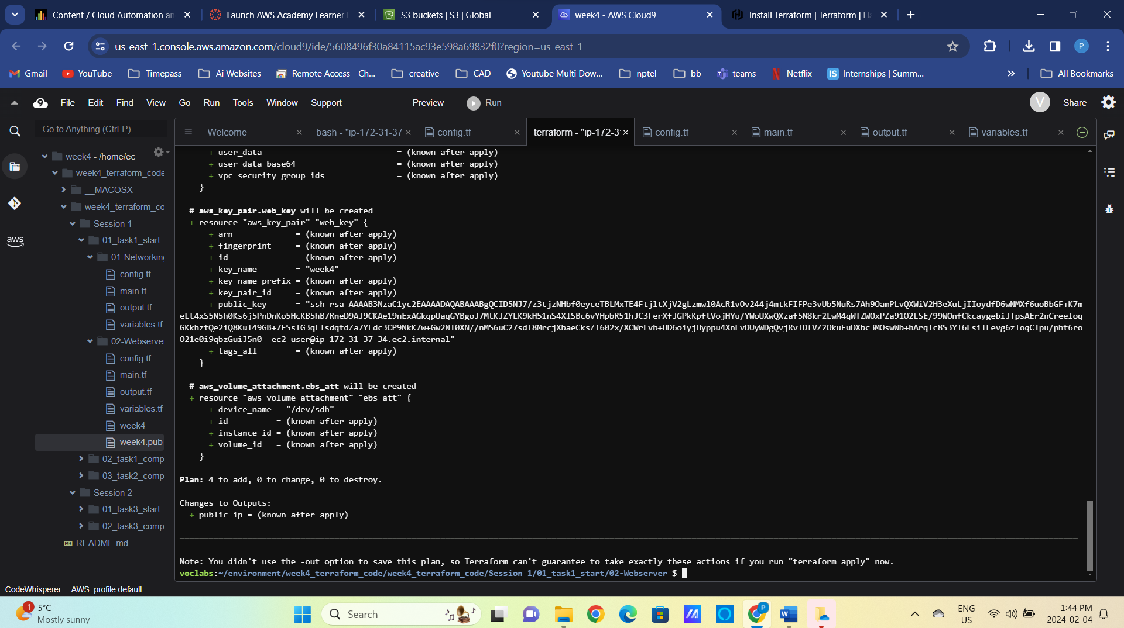

terraform apply –auto-approve

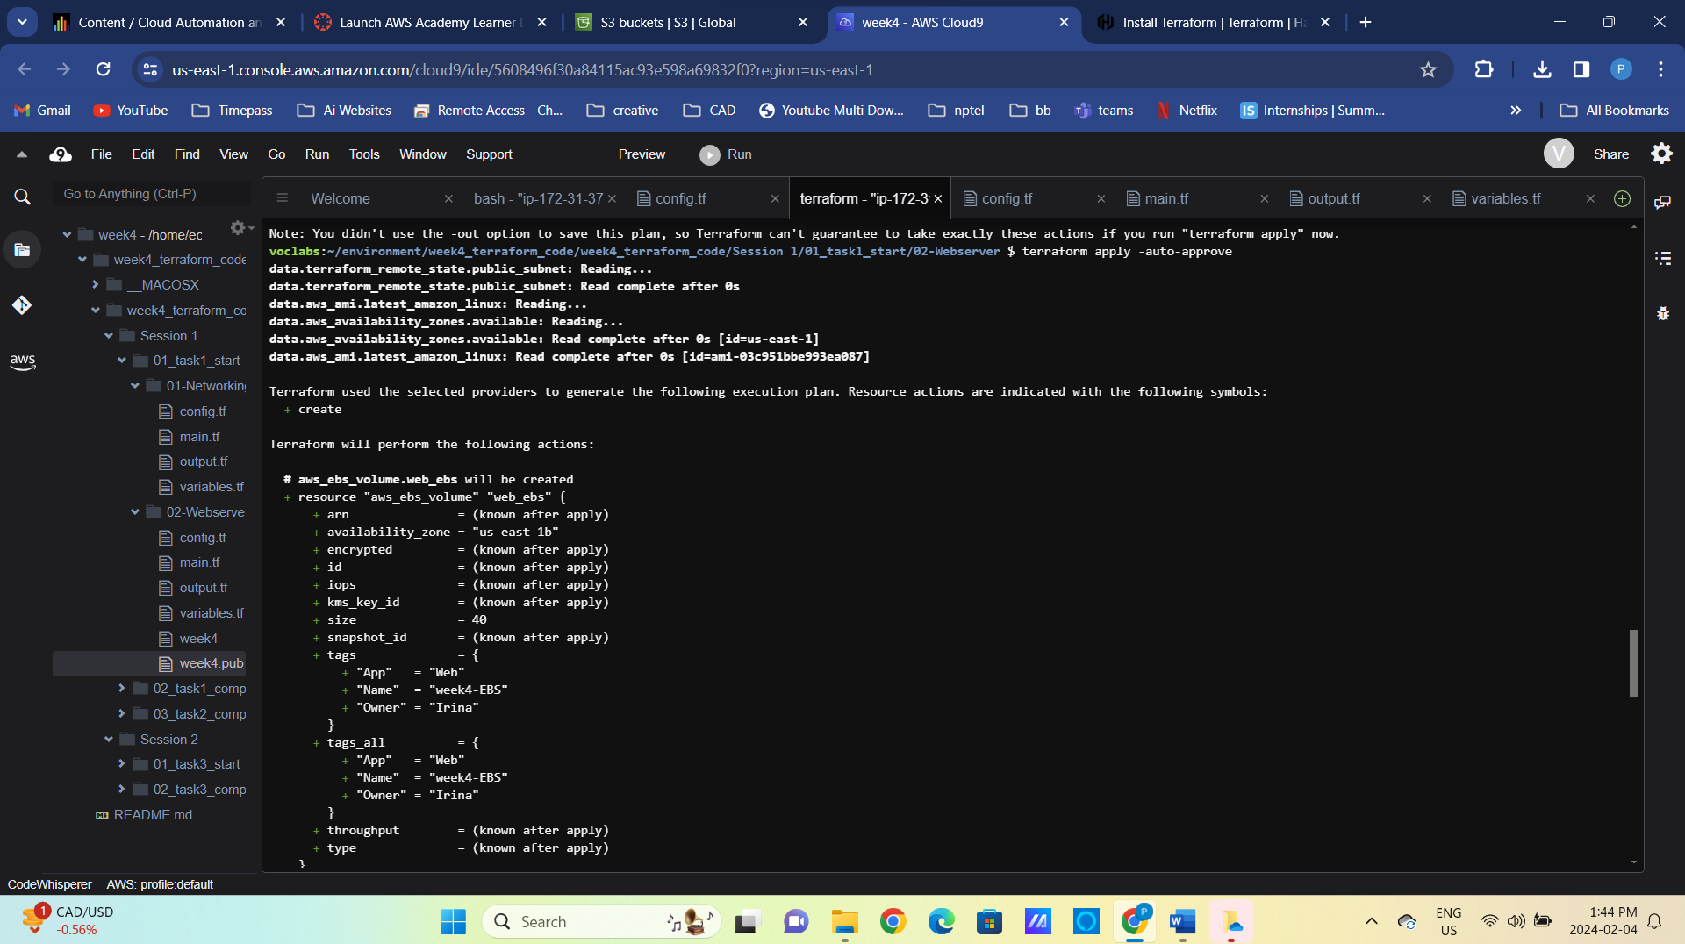

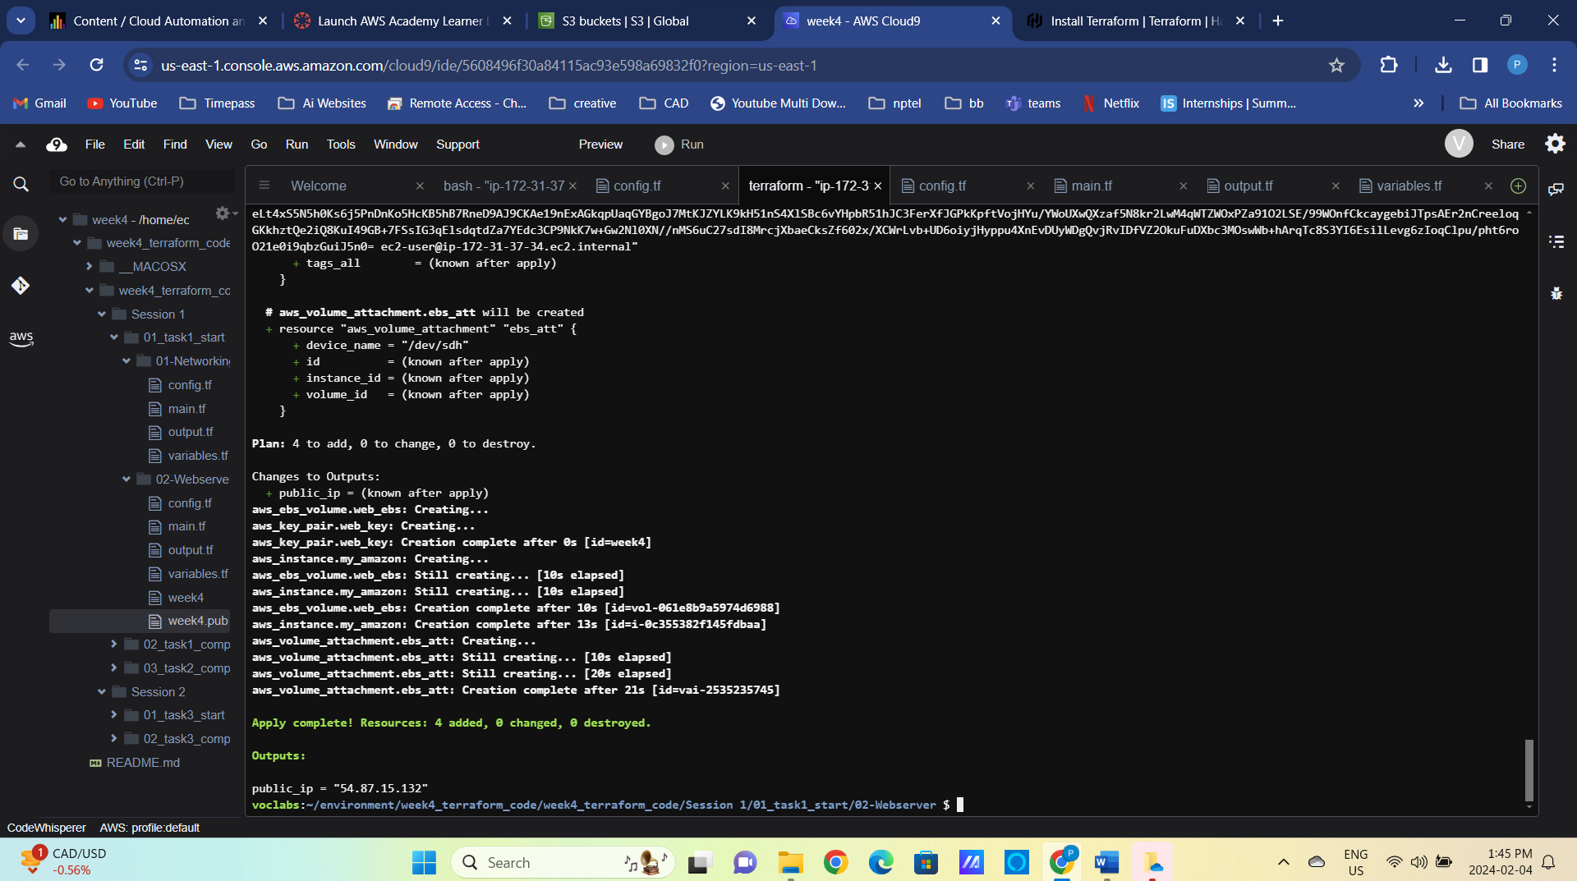

Figure 6 EC2 instance deployment output

1. Remain in the 01-Webserver folder and update the variable.tf and main.tf files to signal current environment (prod/test).   
   **Note:** reference the code in the 02_task1_completed folder to see the final implementation of this task.
2. Add “env” variable to variable.tf and add conditional deployment of EBS (Elastic Block Storage) volume as specified below.

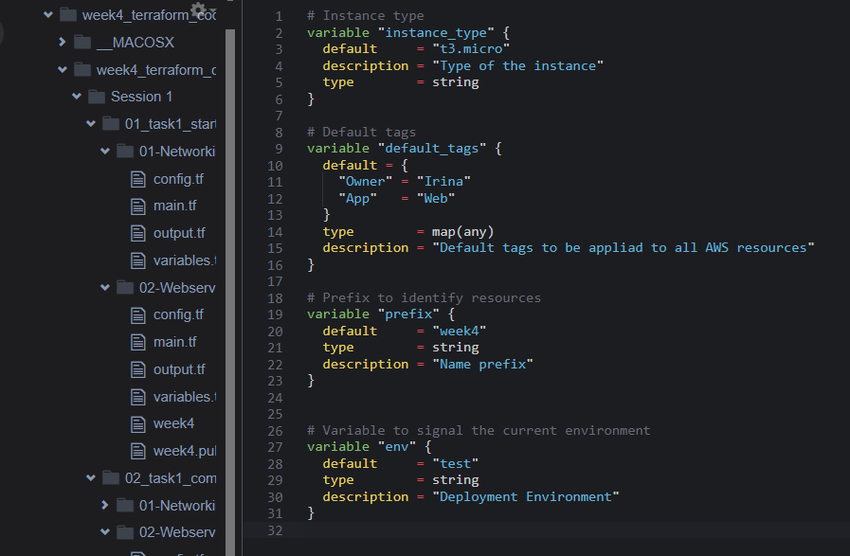

Figure 7 Define "env" variable to specify current environment

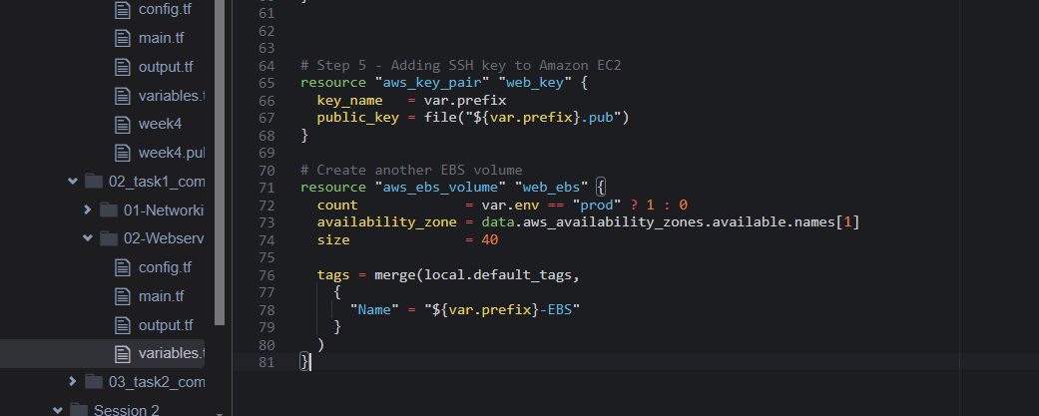

Figure 8 Add condition to EBS volume deployment

Figure 9 Add condition to EBS volume attachment

Conditional encryption of root volume:

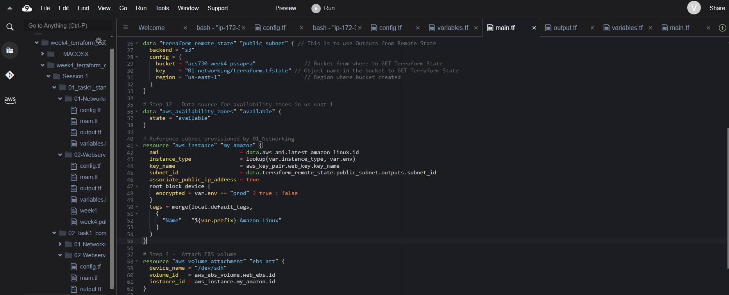

Figure 10 Add condition to root volume encryption

1. Add a map with the instance size per environment to variable.tf

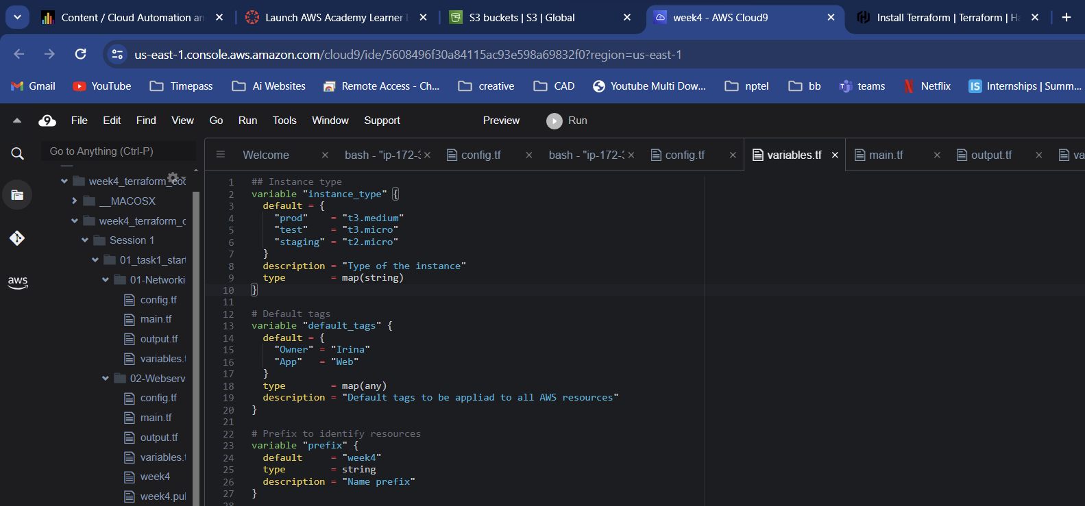Update main.tf to resolve instance type dynamically using lookup function.

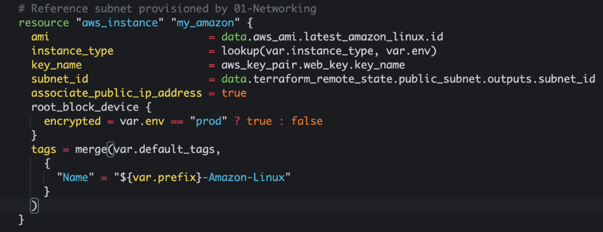

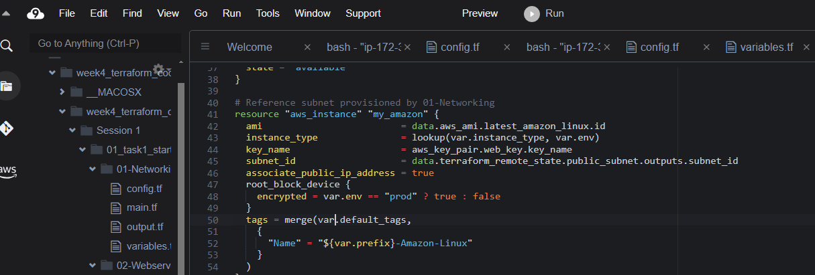

Figure 11 Specify map variable of instance type per environment

Validate and test your code with the commands below

terraform int

terraform validate



terraform plan –var env=test

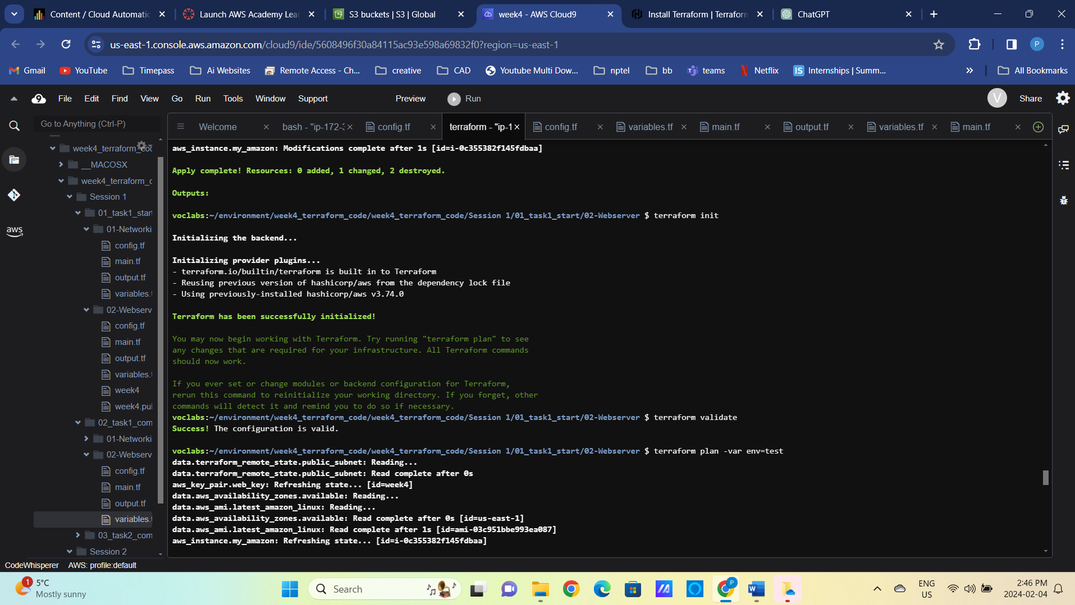

Figure 12 Terraform plan for test environment, instance type t3.micro

terraform plan –var env=prod

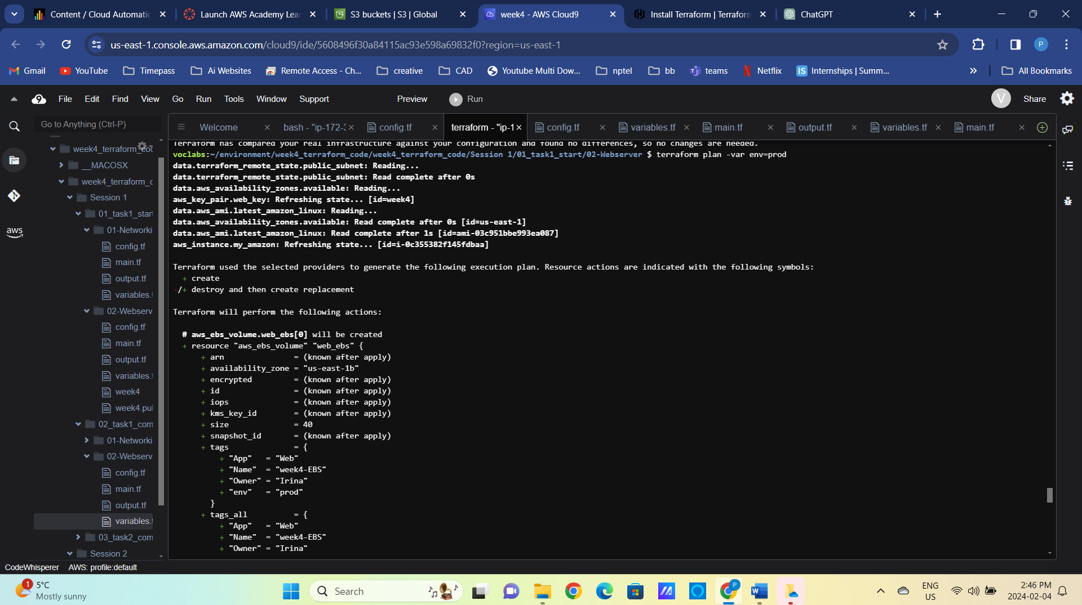

Figure 13 Terraform plan for prod environment, instance type t3.medium and extra volume attached, root volume encrypted

**Do you see the difference between planned deployment of “dev” and “prod” instances? What other changes would you have implemented?**

Deploy the “test” instance.

terraform apply –var env=test

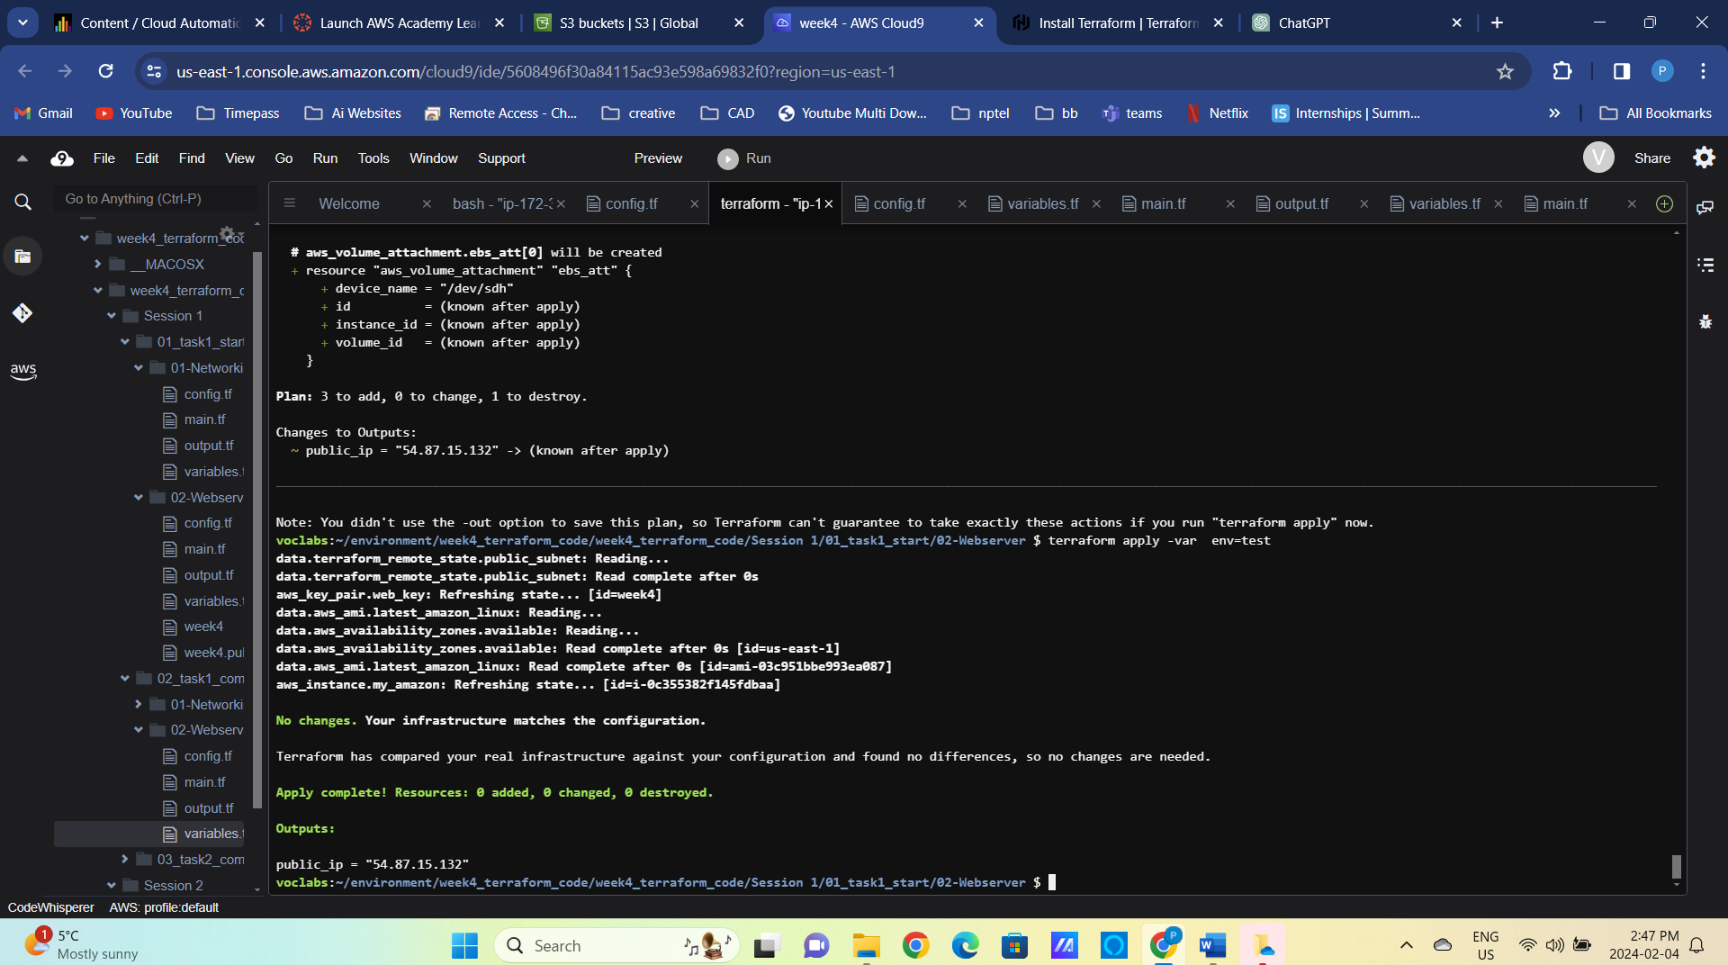

Verify the instance has one EBS volume only.

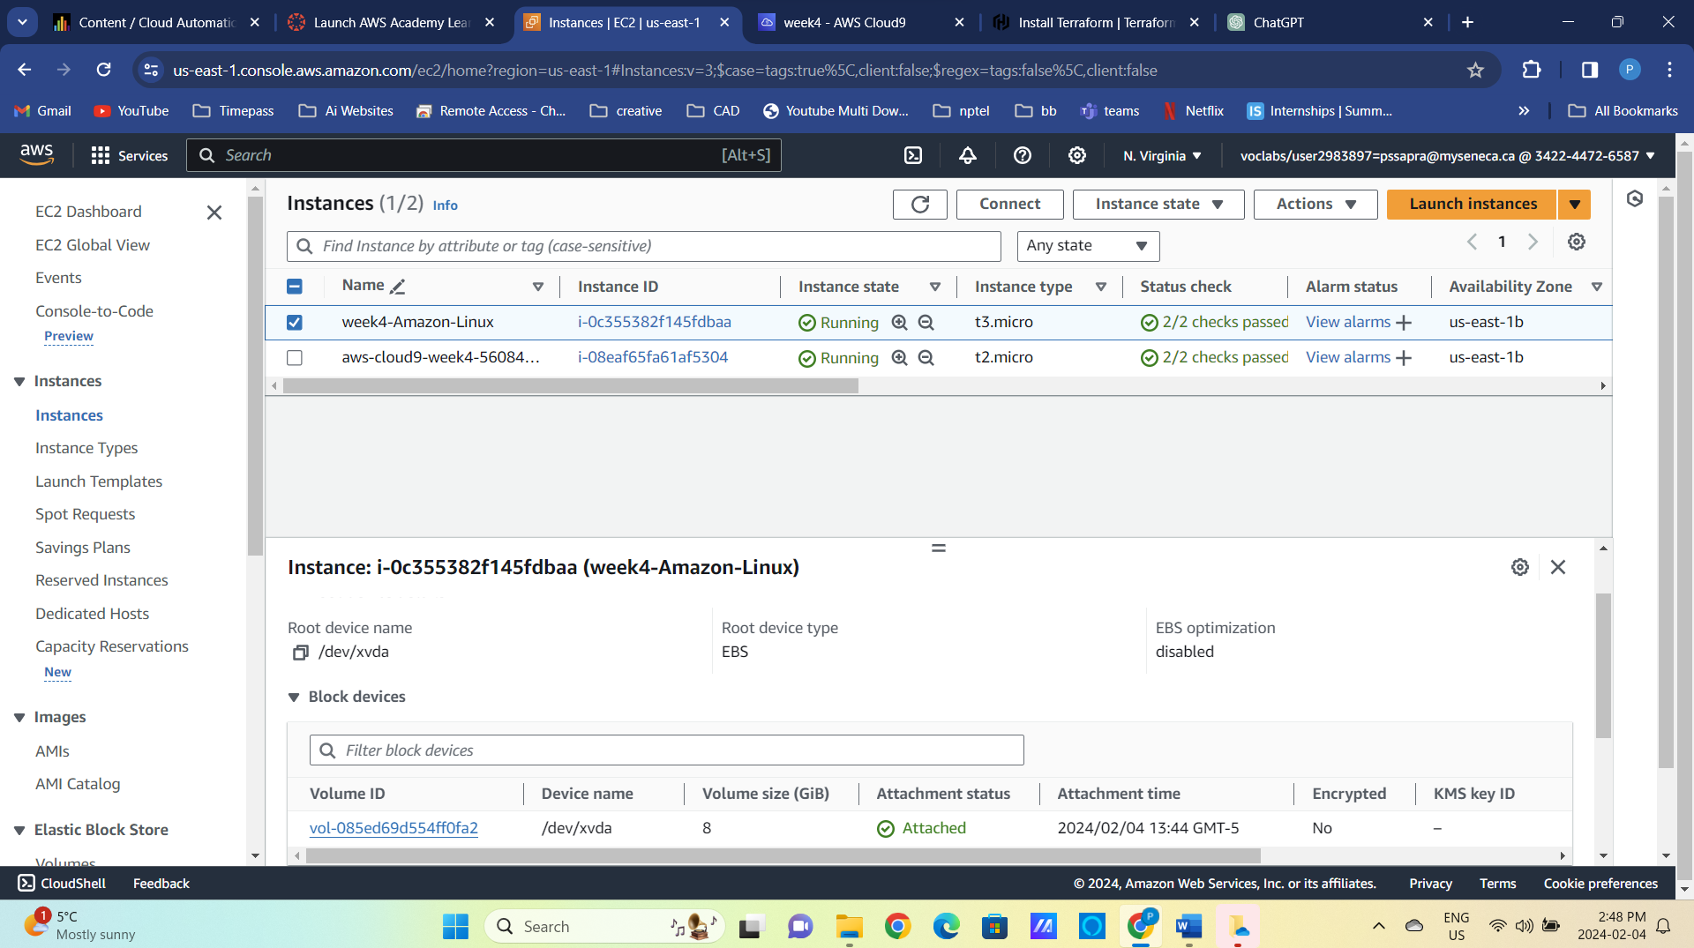

Figure 14 One EBS volume in “test” deployment

Deploy the “prod” instance.

terraform apply –var env=prod

Verify the instance has two EBS volumes.

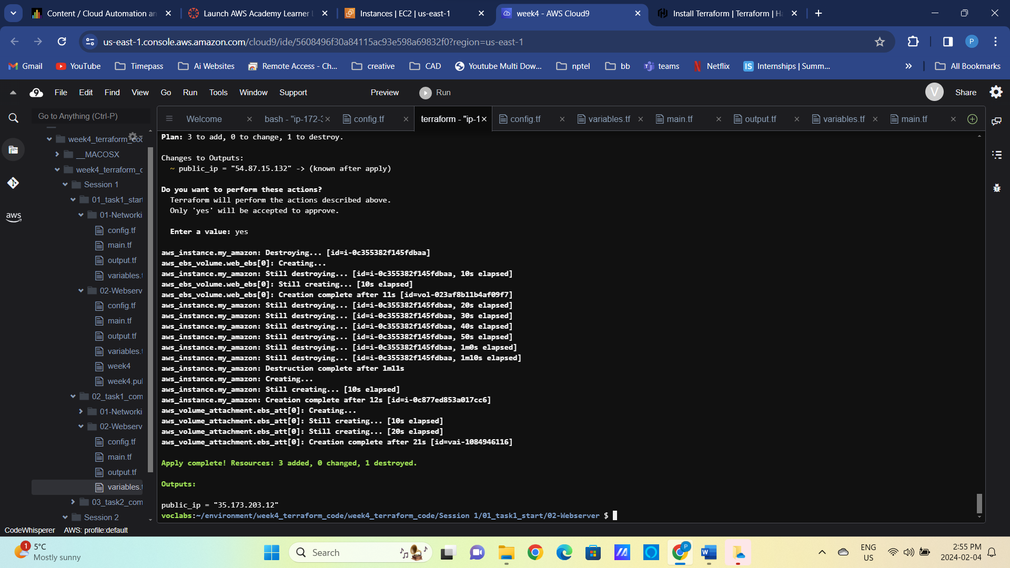

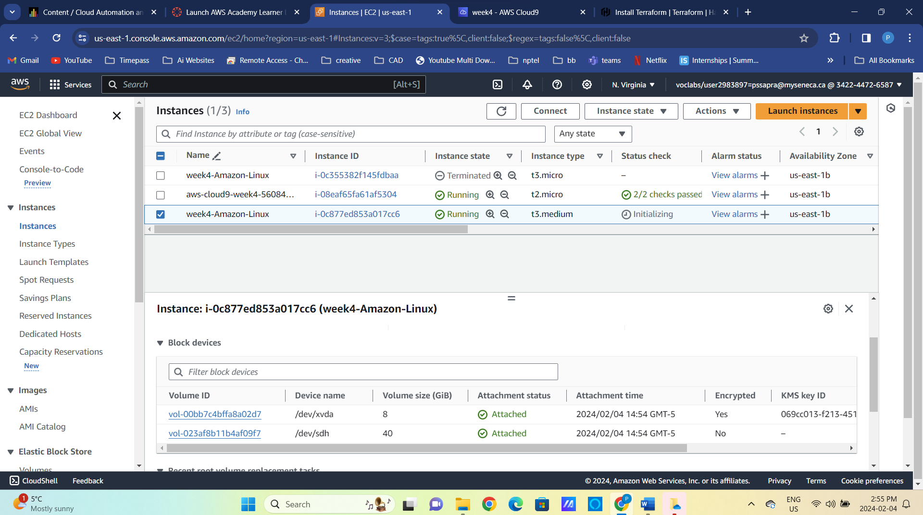

Figure 15 Two EBS volumes in "prod" deployment

1. Improve readability of your environment and add an “env” tag using local variables and re-deploy.

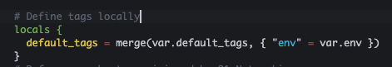

Figure 16 Define tags locally

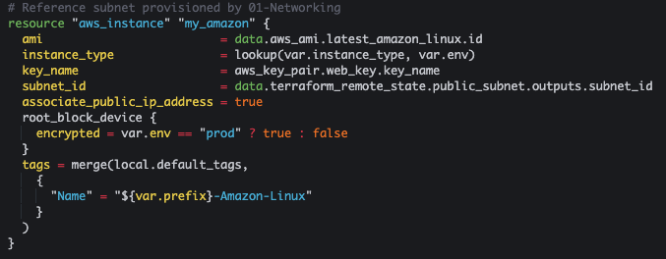

Figure 17 Reference local tags

## Task 2: Using “user_data” and Terraform provisioners to install static website

In this task we will explore the use of “user_data” section of “aws_instance” Terraform and local-exec provisioner to install static web server on our EC2 instance.

1. Add a user_data block to the EC2 deployment. The script in the block should update the package manager, install httpd webserver, start and enable the server.

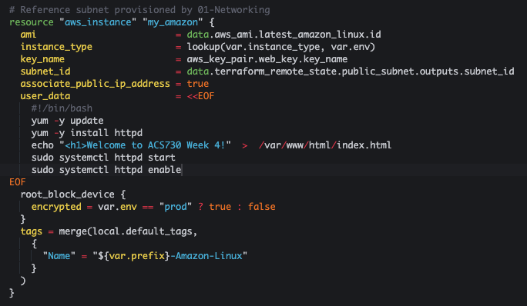

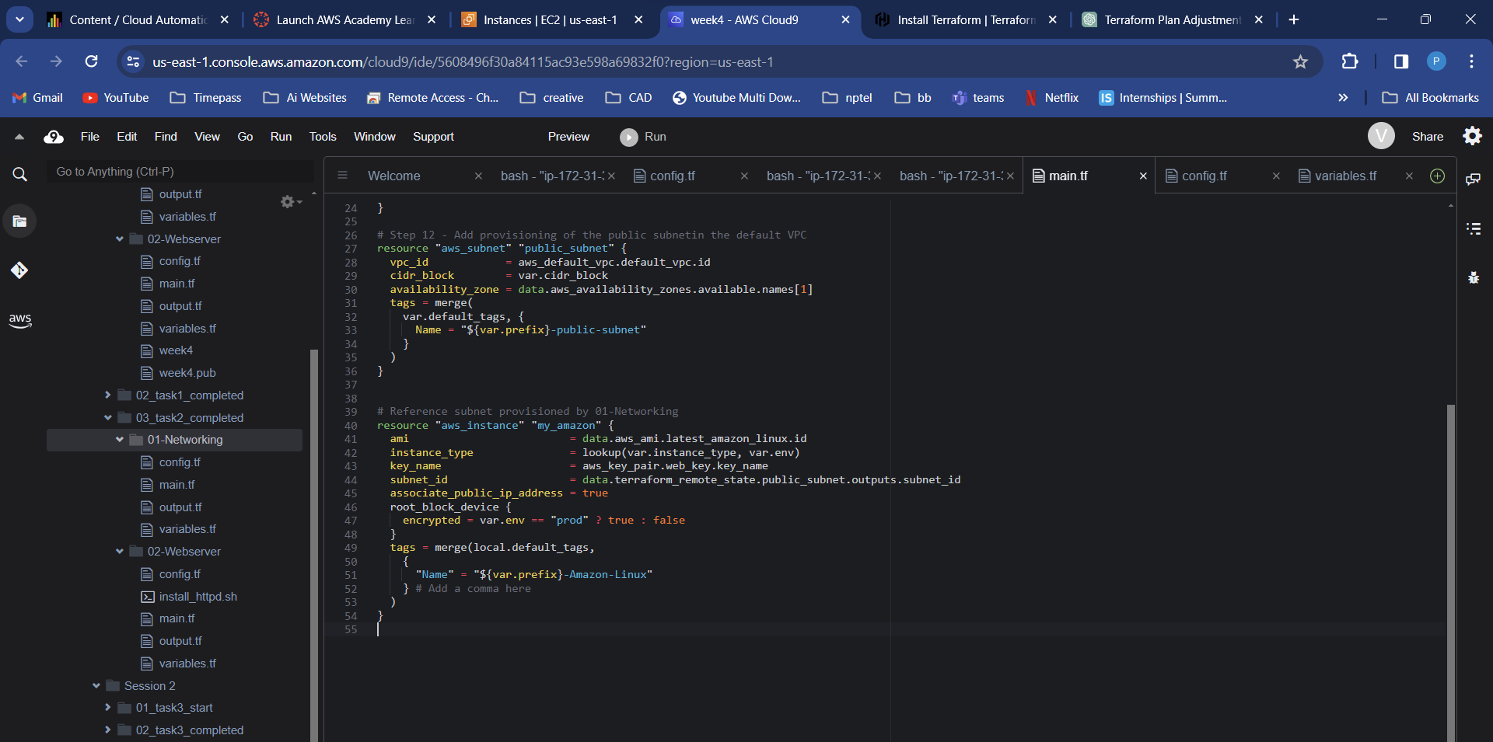  
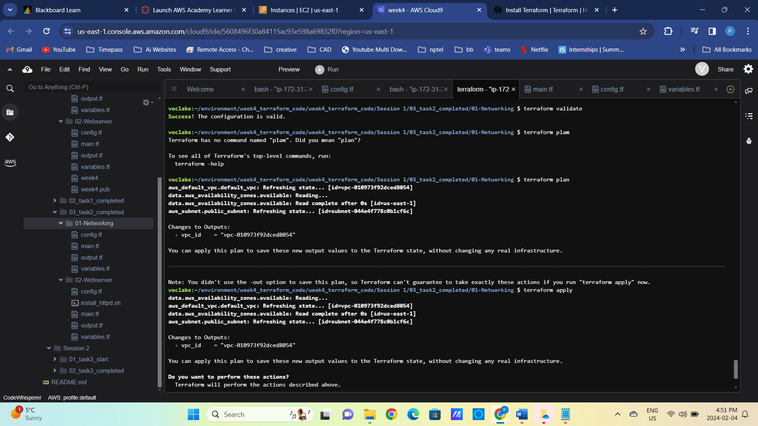

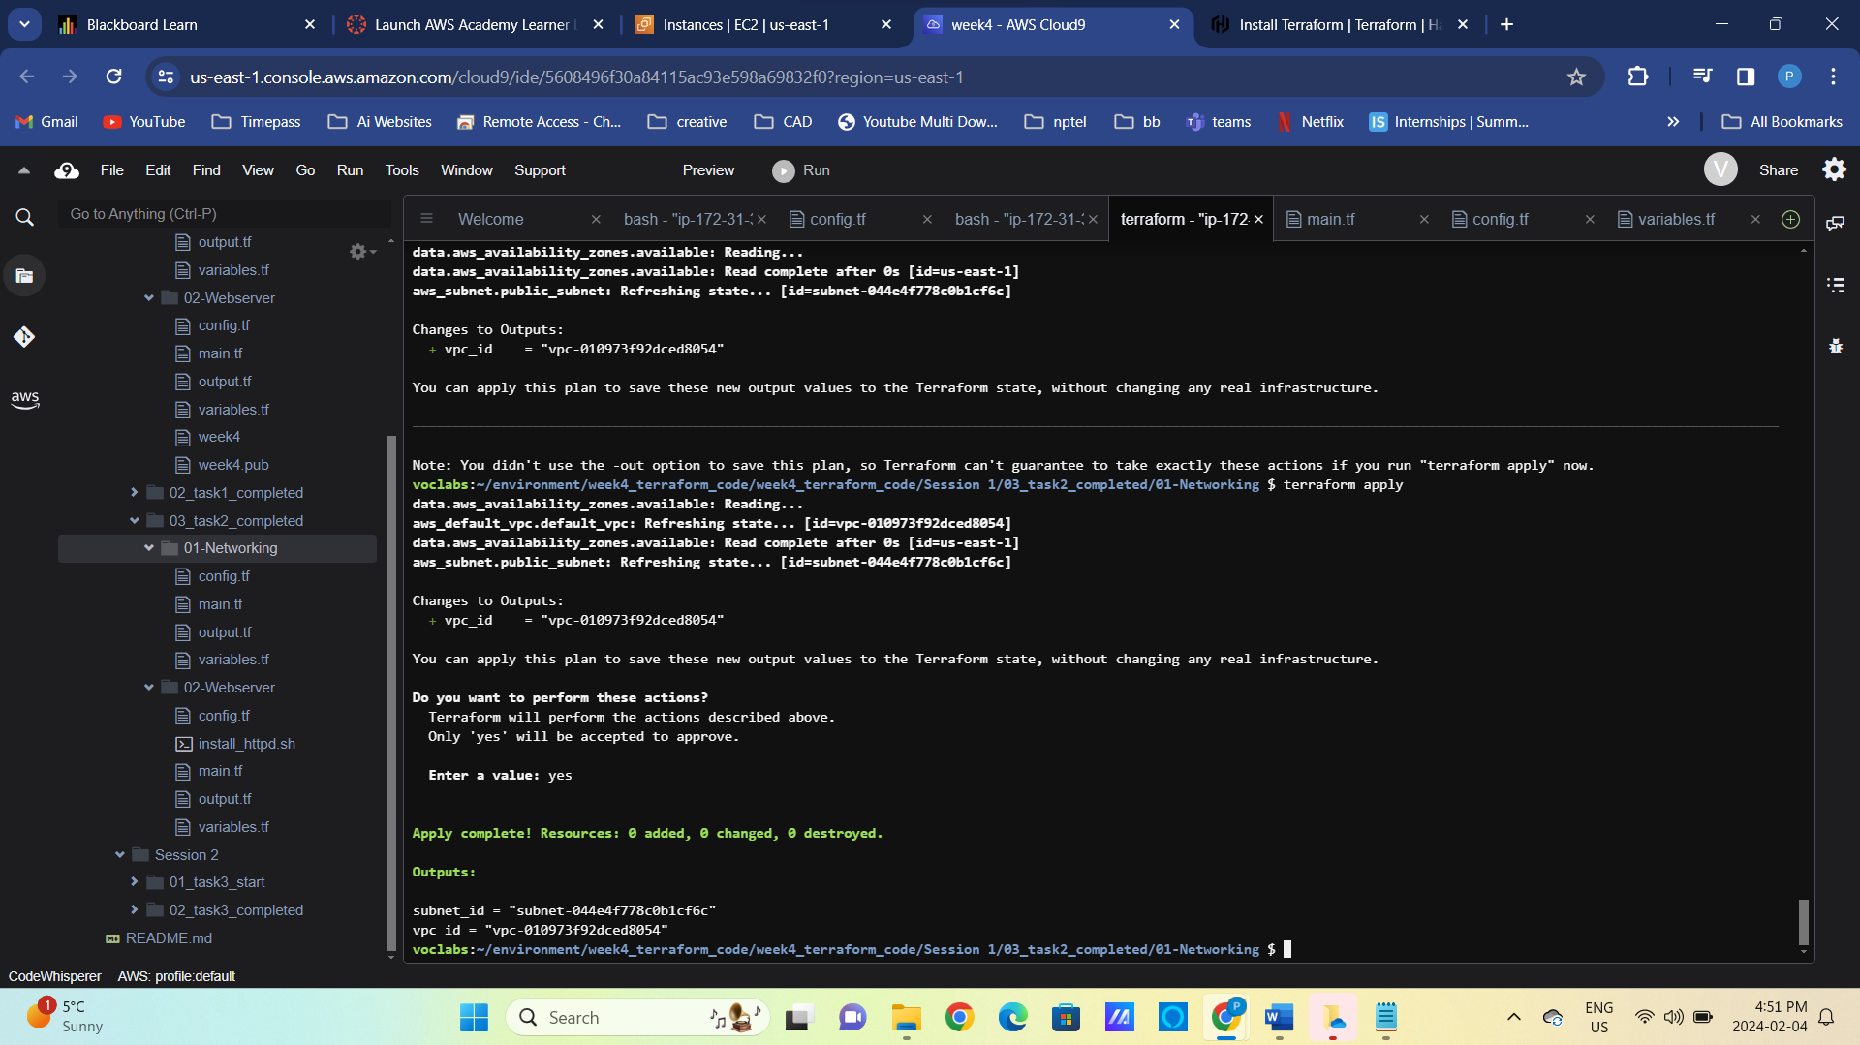

Figure 18 Inline user_data block

Figure 19 Note the public IP

1. Deploy the security group to allow ingress on ports 80 and 22 from everywhere.

Update 01-Networking Terraform configuration “output.tf” to expose VPC id.

Figure 20 Add VPC id to output.tf in 01-Networking module

Redeploy the 01-Netwotking module. Did any of the resources get re-deployed?

cd ../01-Networking/

terraform plan

terraform apply

Add security group to your EC2 instance and redeploy 02-Webserver code. Notice the use of “terraform_remote_state” in the configuration below.

Figure 21 Security Group Definition, notice the use of the outputs

Figure 22 Add Security Groups reference to "aws_instance" resource

cd -

terraform plan

terraform apply

1. Log into deployed EC2 instance and examine the logs related to the user_data script execution.

ssh -i week4 [ec2-user@3.80.102.168](mailto:ec2-user@3.80.102.168)

ssh -i week4 ec2-user@35.173.203.12

sudo vi /var/log/cloud-init-output.log # Check initialization logs

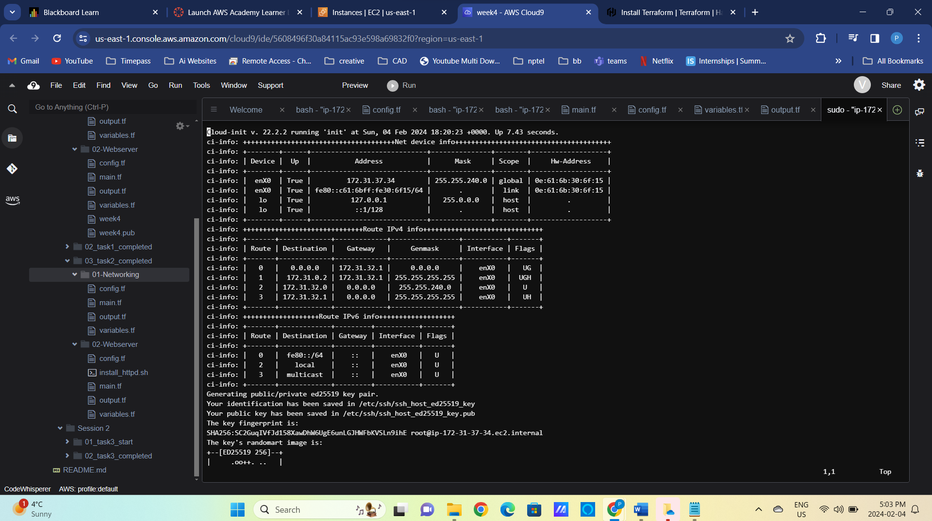

Figure 23 Is httpd installed?

sudo systemctl httpd status $ Is httpd running?

Figure 24 Is httpd running?

sudo rpm -q httpd # Is httpd installed?   
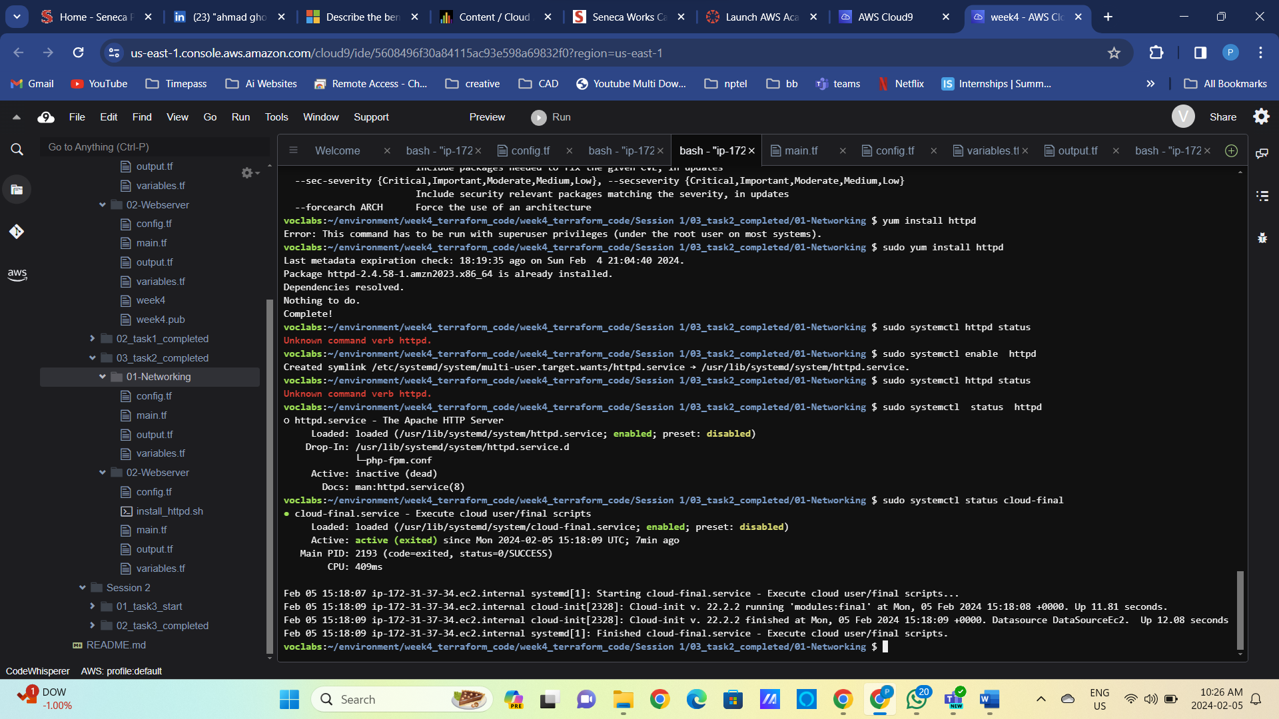

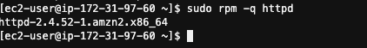

Figure 25 Is httpd installed?

sudo systemctl status cloud-final # What happen to the service?

Figure 26 Cloud-final service failed to start

sudo journalctl -u cloud-final # Check service logs

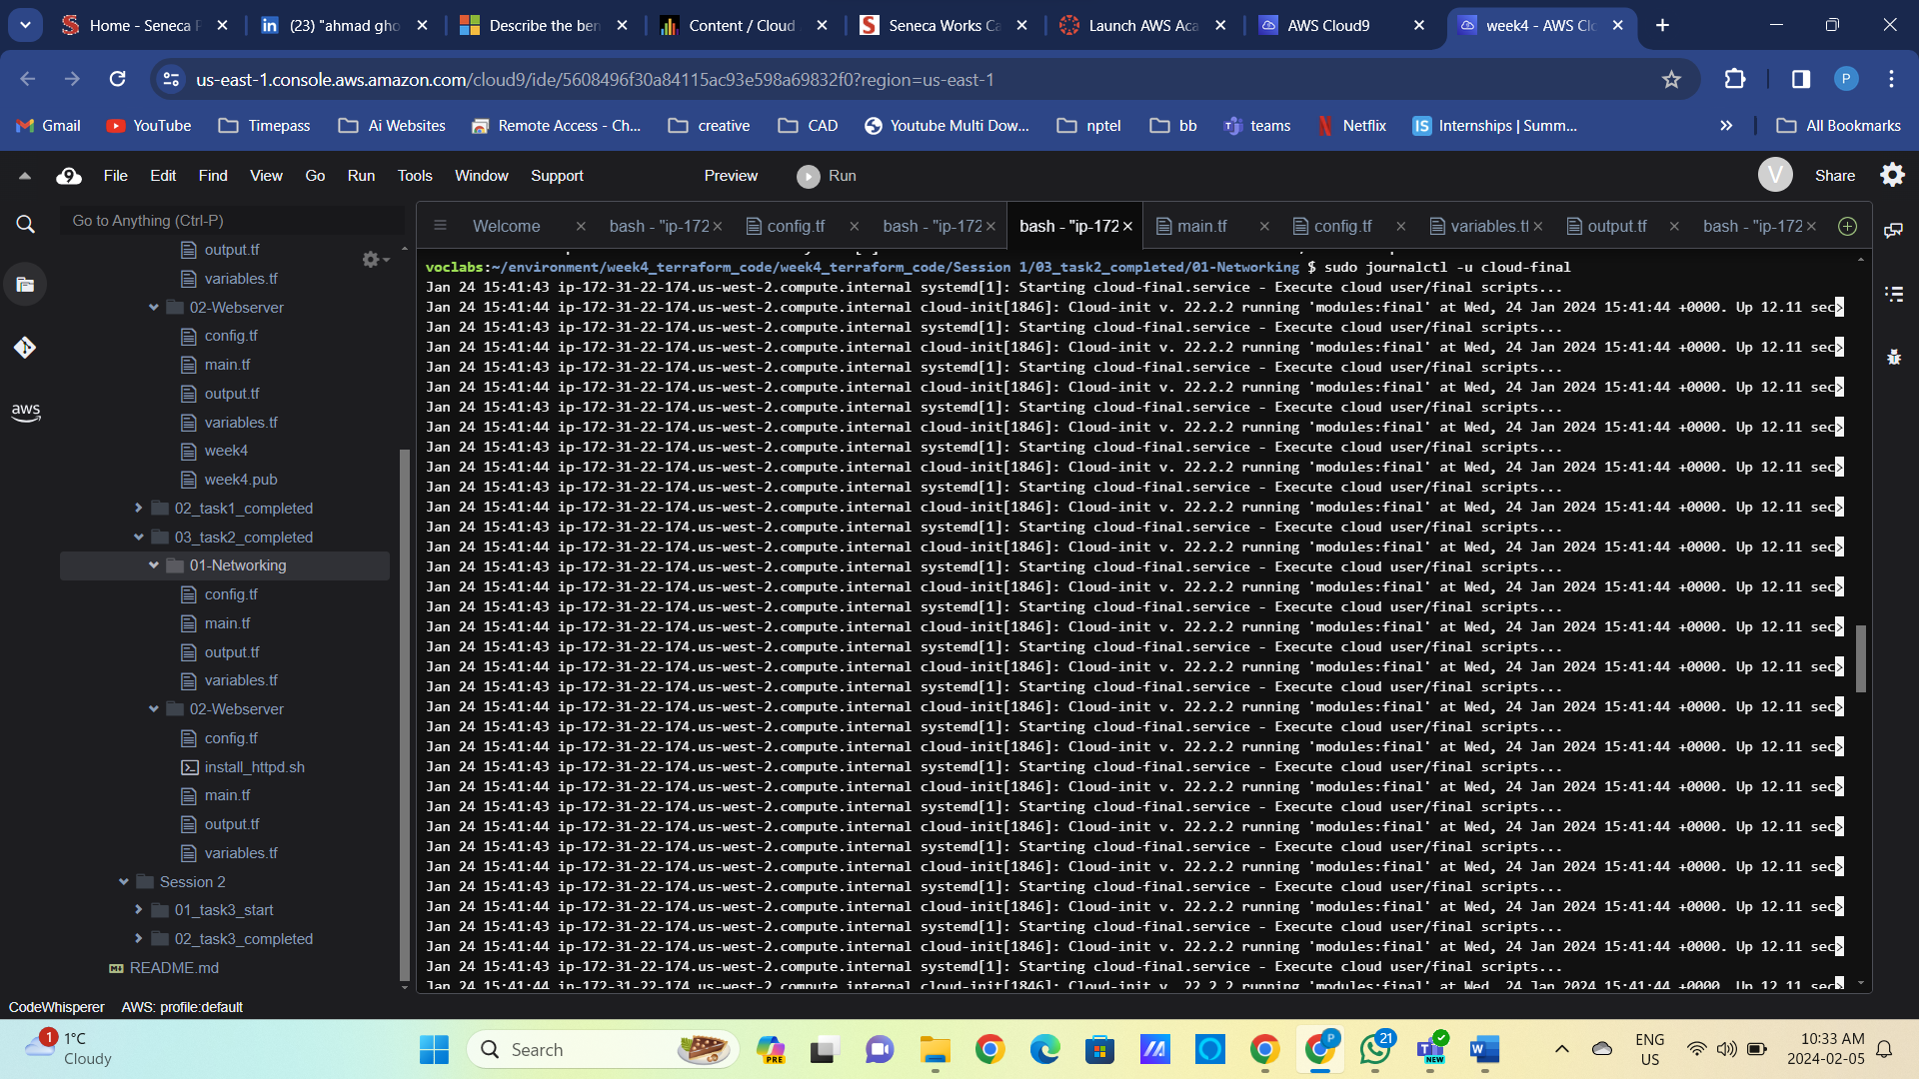

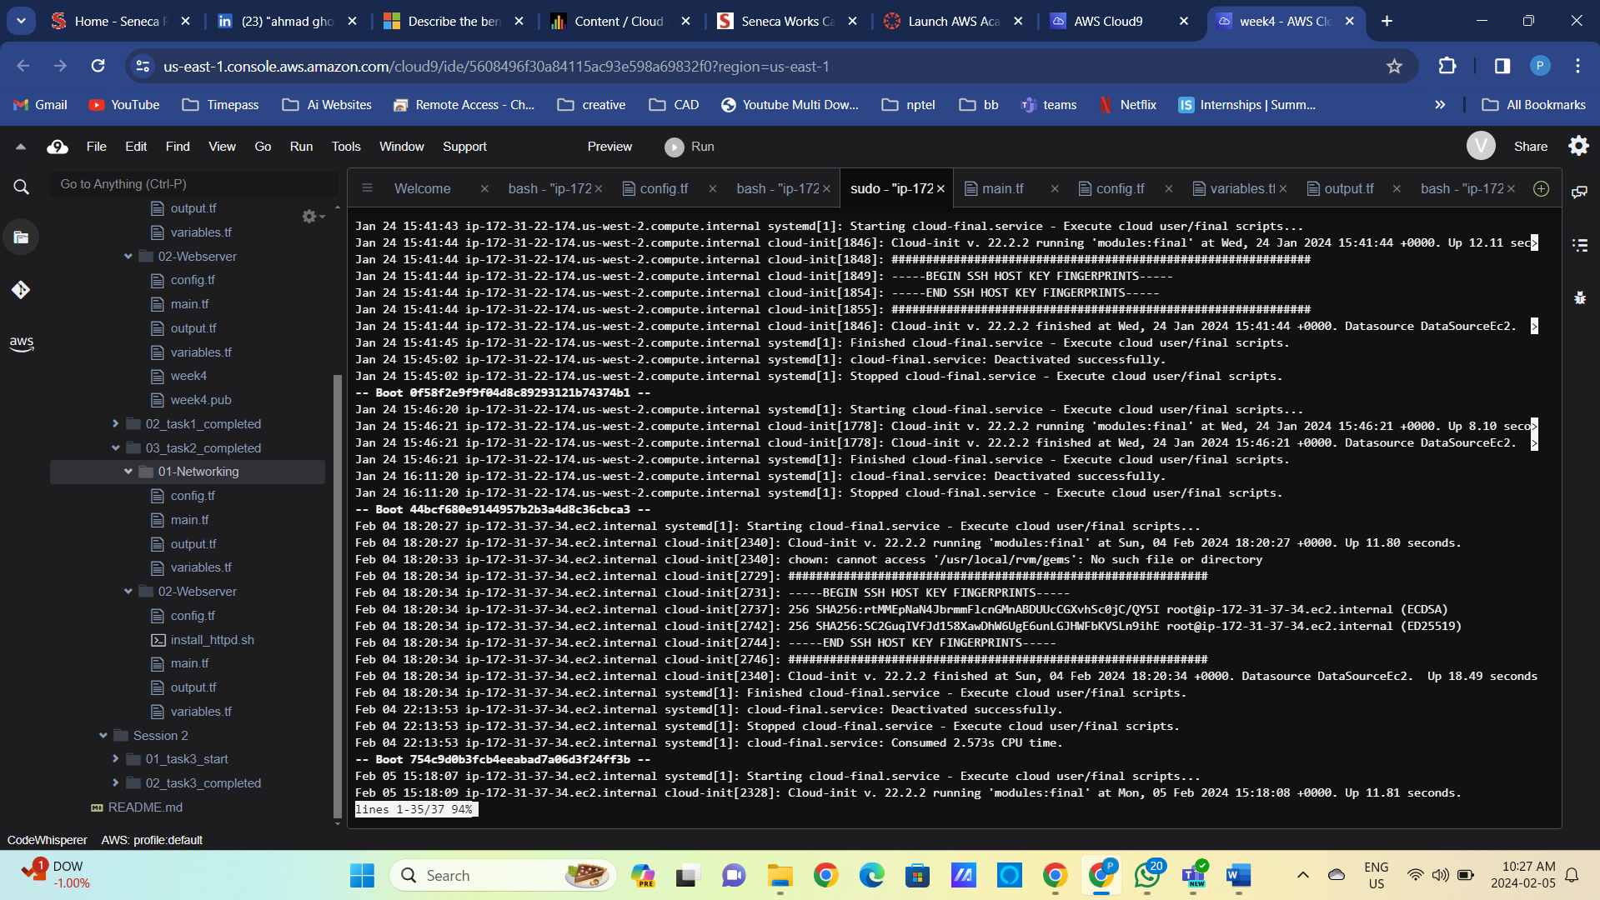

Figure 27 Linux service logs, note the “Unknown operation ‘httpd’”

1. Reproduce the problem locally on EC2.

sudo systemctl httpd start

sudo systemctl list-units --type=service  
  
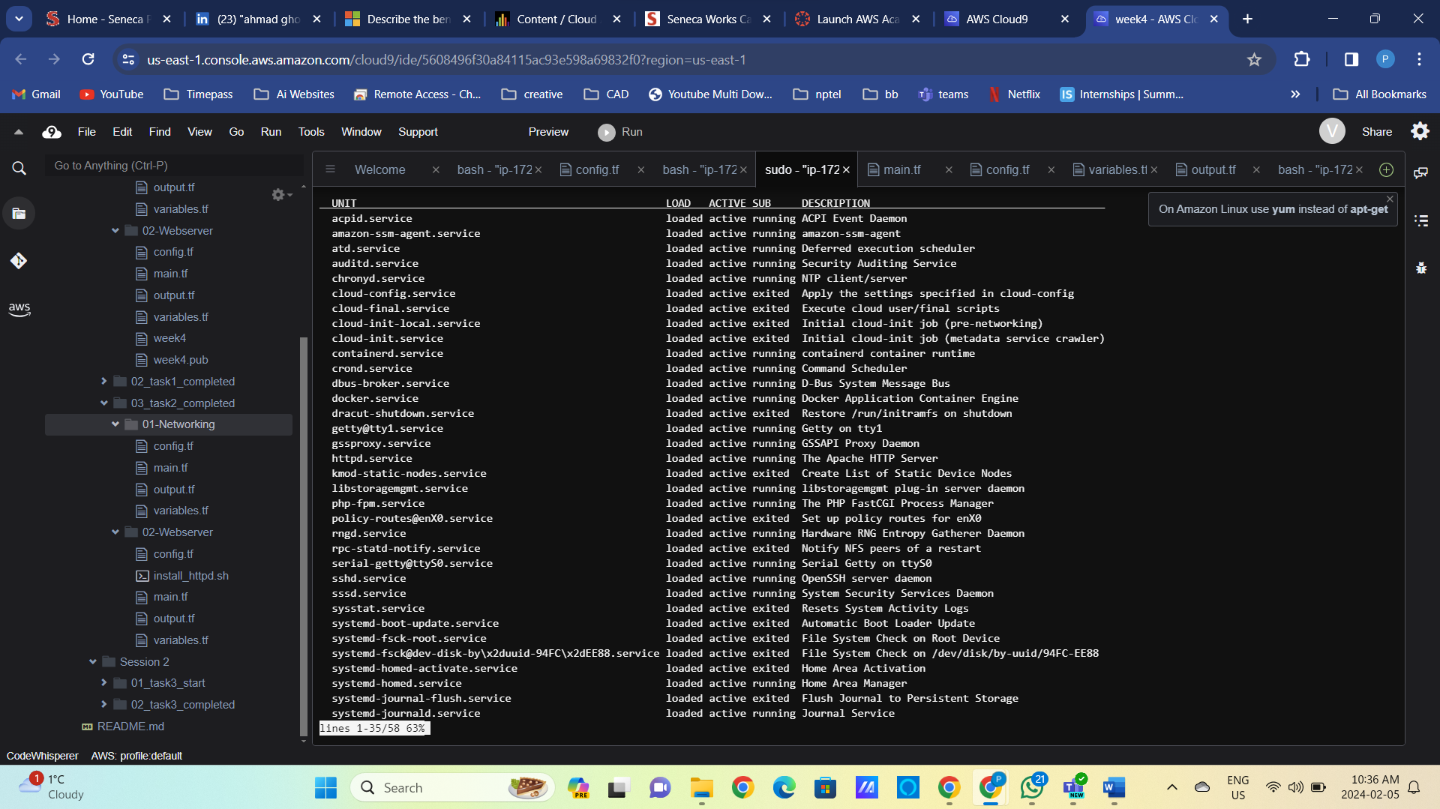

Figure 28 Service start command errors out

1. Fix the service start problem

sudo systemctl start httpd

sudo systemctl status httpd

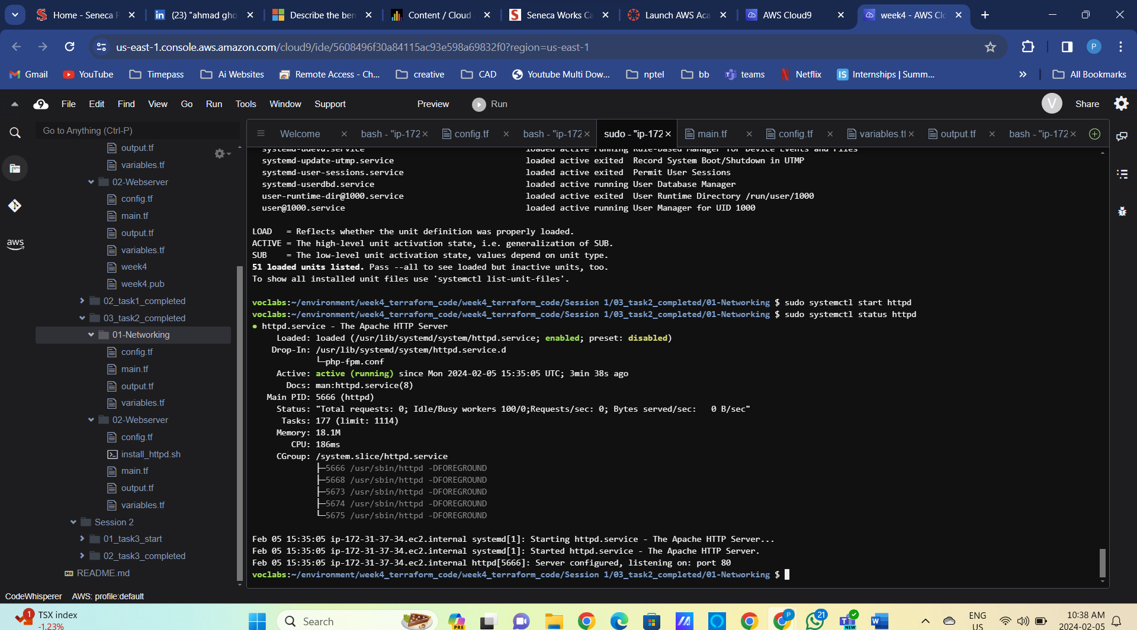

curl localhost

Figure 29 Webservice started successfully

Figure 30 Webserver in the Web browser

1. We created configuration drift! Our deployment configuration is different than our local configuration on EC2. Let us fix it!

Figure 31 Fix the systemctl commands

**Important**! Even though we changed configuration script only, the EC2 instance is fully redeployed! Is it a good thing in production?

Mark the new public IP of the EC2 instance and see if the webserver is still available.

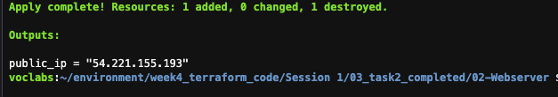

Figure 32 Instance redeployed with a new public IP

Figure 33 Web server is running

1. Refactor our “user_data” section to reference file instead of the inline code.

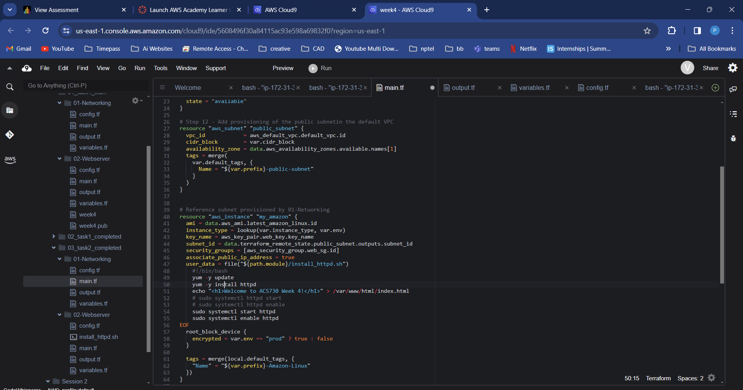

Figure 34 Replace inline code with the file reference

**Important** We changed the message in static HTML only, yet the instance is redeployed. Is it a good thing in production?

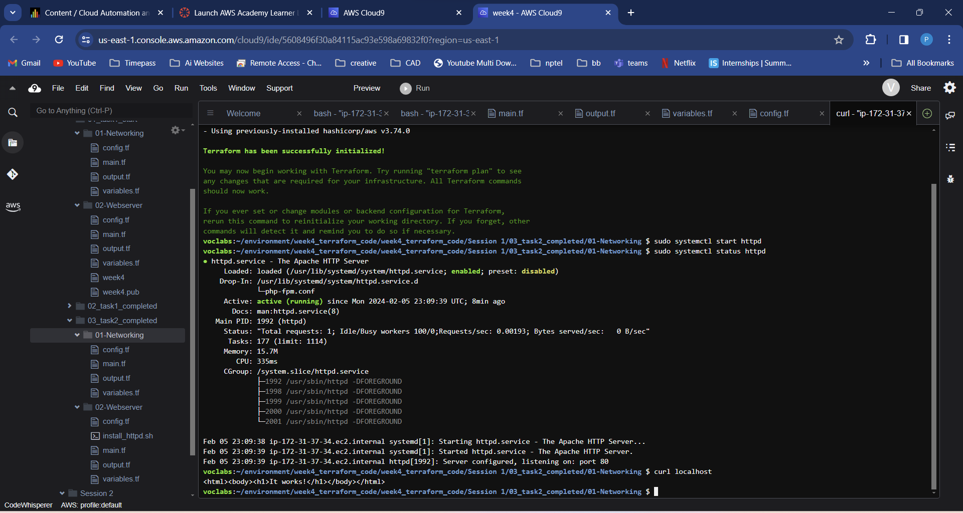

Figure 35 Updated message

1. Destroy all the infrastructure we have provided so far. Task 3 will start from the beginning.

terraform destroy –auto-approve

cd ../01-Networking

terraform destroy –auto-approve